Docker challenge -01

Overall Task Title
End-to-End DevOps Containerization, CI/CD Automation & Cloud Deployment Using Docker, Jenkins, Terraform, and AWS
Objective
- Create custom Docker images using Dockerfiles for multiple application stacks (Frontend, Java, Node.js, Python).
- Build, run, and validate Docker containers locally and on AWS EC2.
- Push Docker images to Docker Hub and Amazon ECR.
- Provision AWS infrastructure (EC2 instance) using Terraform.
- Install and configure Jenkins on EC2.
- Create a Jenkins job to automate Docker image build and push.
- Use Docker Compose to deploy a multi-container WordPress application with MySQL.
- Gain hands-on experience with containerization, CI/CD, infrastructure as code, and cloud services.
Prerequisites
- AWS account with IAM permissions (EC2, ECR, VPC)
- Docker & Docker Compose installed
- Terraform installed
- Jenkins installed and configured
- Git installed
- Docker Hub account
- AWS CLI configured
- Open security group ports:
  - 22 (SSH)
  - 8080 / 8084 / 8085 / 3000 (apps)
  - 8080 (Jenkins)
- Basic knowledge of:
  - Docker & containers
  - Jenkins pipelines
  - Terraform
  - Linux commands

Create a customized Docker image using a Docker file.
Steps Performed
1. Created a working directory
You created a new directory named docker in the root user’s home location.
mkdir docker
2. Moved into the directory
You navigated into the newly created directory.
cd docker
3. Verified directory contents
You listed the contents to confirm the directory was empty.
ls
4. Created the Dockerfile
You created and opened a Dockerfile using the vi editor.
vi dockerfile
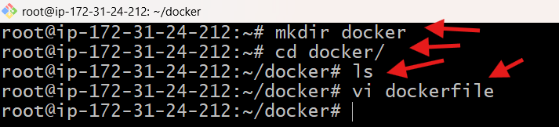
5. Added Dockerfile instructions
Inside the Dockerfile, you added the following logic:
- Used Amazon Linux as the base image
- Updated system packages
- Installed nginx
- Cleaned yum cache
- Created the nginx HTML directory
- Created index.html directly at /usr/share/nginx/html/
- Exposed port 80
- Configured nginx to run in foreground

FROM amazonlinux:latest
RUN yum update -y && \
yum install -y nginx && \
yum clean all
RUN mkdir -p /usr/share/nginx/html
RUN echo "<h1>Hello from Nginx Docker</h1>" > /usr/share/nginx/html/index.html

EXPOSE 80

CMD ["nginx", "-g", "daemon off;"]
You saved and exited the file.
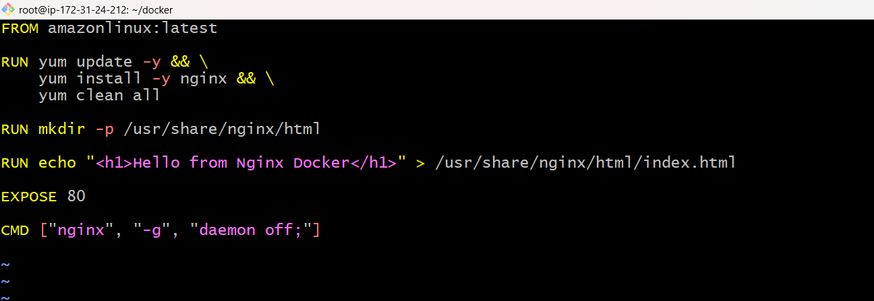
6. Built the Docker image
You built a Docker image named sample-nginx.
docker build -t sample-nginx .
During this step:
- Docker pulled the amazonlinux:latest image
- Installed nginx successfully
- Executed all Dockerfile steps
- Created intermediate layers
- Built the final image
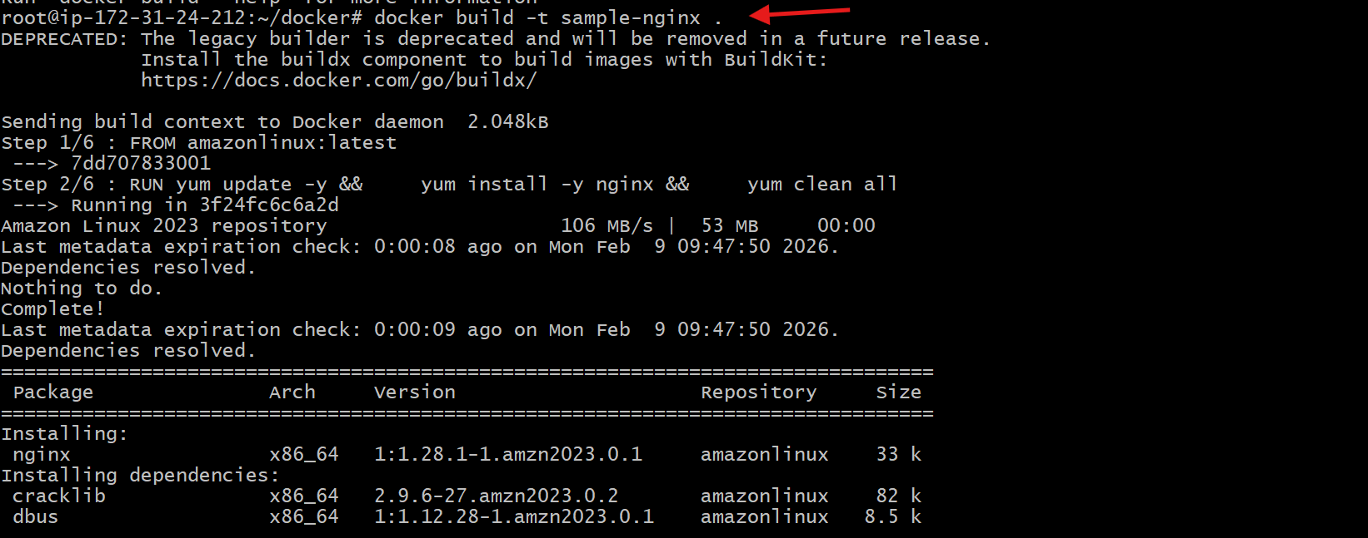
7. Image build completed successfully
Docker displayed:
Successfully built 0cb2b346ccaf
Successfully tagged sample-nginx:latest
This confirms the image was created without errors.
8. Verified the Docker image
You listed Docker images to confirm creation.
docker images
Output showed:
- Repository: sample-nginx
- Tag: latest
- Image ID: 0cb2b346ccaf
- Size: ~213 MB
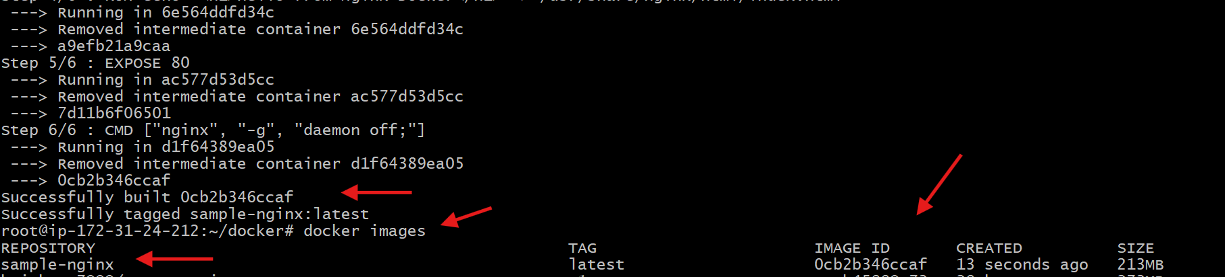
9. Ran the Docker container
You started a container from the previously built image sample-nginx and mapped host port 85 to container port 80.
docker run -itd -p 85:80 sample-nginx
What happened here:
- -i → interactive mode
- -t → allocates terminal
- -d → runs container in background
- -p 85:80 → host port 85 mapped to nginx port 80
- sample-nginx → image name
Docker returned a container ID, confirming the container started successfully.
10. Verified running container
You checked the running containers using:
docker ps
Output confirmed:
- Container is running
- Image used: sample-nginx
- Command: nginx -g daemon off;
- Status: Up
- Port mapping: 0.0.0.0:85 -> 80/tcp
- Container name auto-generated (example: magical_swirl)
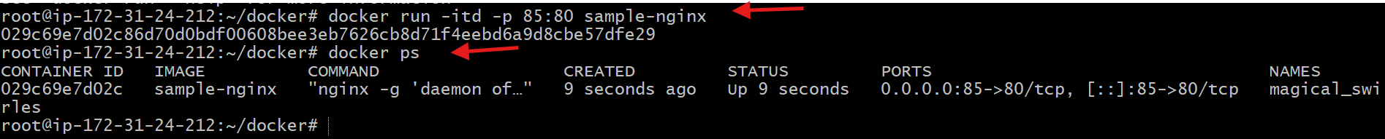
11. Accessed application from browser
You opened a browser and accessed the application using the public IP and port:
http://34.230.91.42:85
12. Verified application output
The browser displayed:
Hello from Nginx Docker
This confirms:
- Nginx is running correctly
- index.html exists at /usr/share/nginx/html/index.html
- Port mapping is working
- Docker container is serving web content successfully
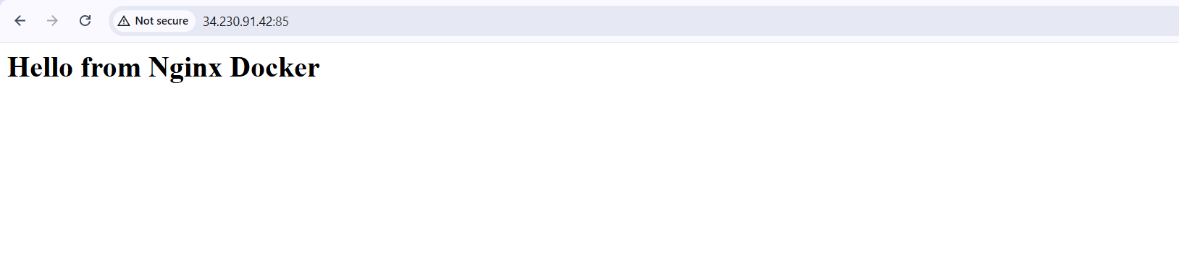

Push the image to Docker Hub.
Steps Performed (Tagging & Pushing to Docker Hub)
1. Tagged the local Docker image
You tagged the existing local image sample-nginx:latest with your Docker Hub username so it can be pushed to Docker Hub.
docker tag sample-nginx:latest krishnav7090/sample-nginx:latest
This created a new tag pointing to the same image ID.
2. Verified the image tagging
You listed the Docker images to confirm the new tag exists.
docker images
The output showed:
- sample-nginx:latest
- krishnav7090/sample-nginx:latest
Both had the same IMAGE ID, confirming correct tagging.
3. Pushed the image to Docker Hub
You pushed the tagged image to Docker Hub.
docker push krishnav7090/sample-nginx:latest
Docker:
- Uploaded required layers
- Skipped existing layers
- Generated a digest confirming success
4. Push completed successfully
The push finished with:
- All layers pushed or reused
- Image digest generated
- No errors
This confirms the image was uploaded successfully.
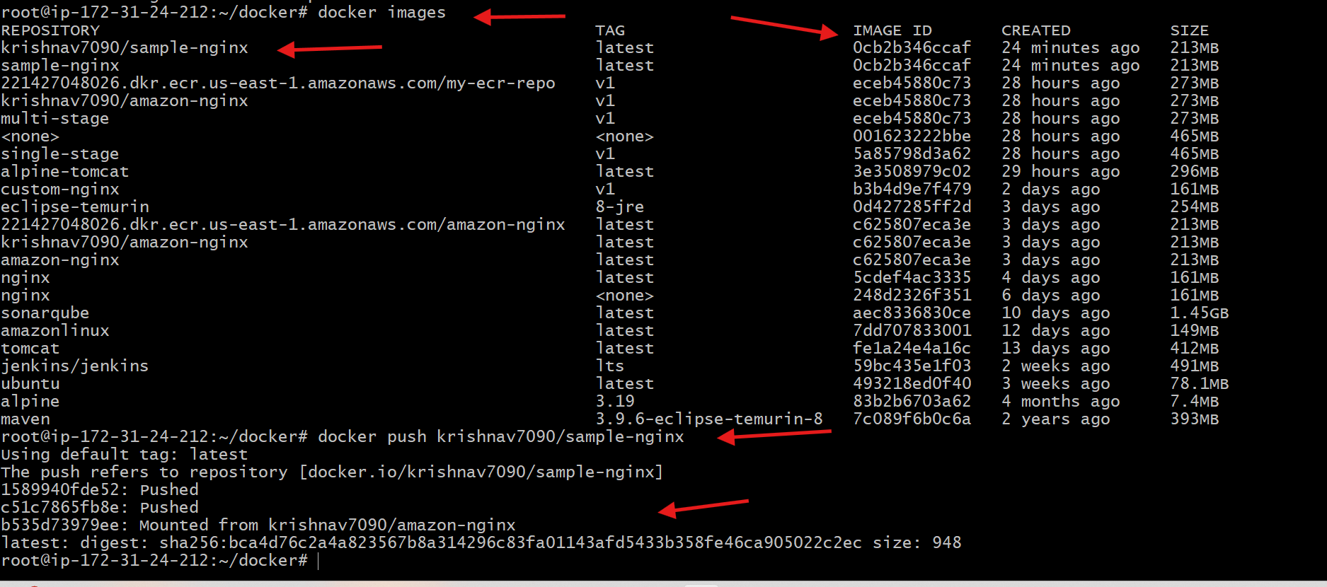
5. Verified image on Docker Hub
You opened Docker Hub (via Docker Desktop → My Hub) and verified:
- Repository name: krishnav7090/sample-nginx
- Tag: latest
- Image visible and available for pull
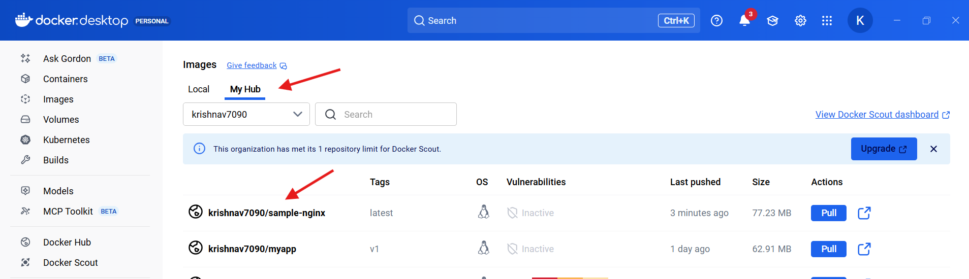

Push the same image to Amazon ECR.
Steps Performed (Pushing Image to Amazon ECR)
1. Logged in to Amazon ECR
You authenticated Docker with Amazon ECR using AWS CLI.
aws ecr get-login-password --region us-east-1 \
| docker login --username AWS --password-stdin 221427048026.dkr.ecr.us-east-1.amazonaws.com
Result:
- Login succeeded
- Docker is now authorized to push images to ECR
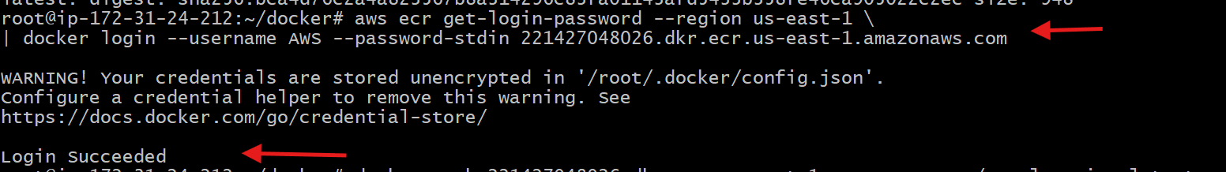
2. Tagged the local Docker image for ECR
You tagged the existing local image sample-nginx:latest with the Amazon ECR repository URI.
docker tag sample-nginx:latest \
221427048026.dkr.ecr.us-east-1.amazonaws.com/sample-nginx:latest
This created a new tag pointing to the same image ID.
3. Verified the image tags
You listed Docker images to confirm tagging.
docker images
Confirmed:
- sample-nginx:latest
- 221427048026.dkr.ecr.us-east-1.amazonaws.com/sample-nginx:latest
Both have the same IMAGE ID, proving it is the same image.
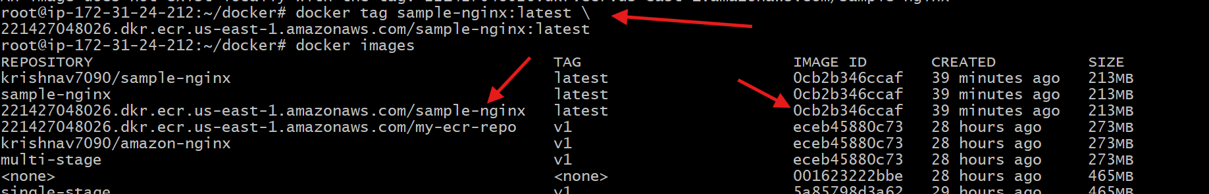
4. Created the ECR repository
You created the required ECR repository named sample-nginx.
aws ecr create-repository \
--repository-name sample-nginx \
--region us-east-1
Output confirmed:
- Repository ARN created
- Repository URI generated
- Encryption enabled (AES-256)
5. Pushed the image to Amazon ECR
You pushed the tagged image to the newly created ECR repository.
docker push 221427048026.dkr.ecr.us-east-1.amazonaws.com/sample-nginx:latest
Docker:
- Uploaded image layers
- Reused existing layers where applicable
- Generated image digest
Push completed successfully.
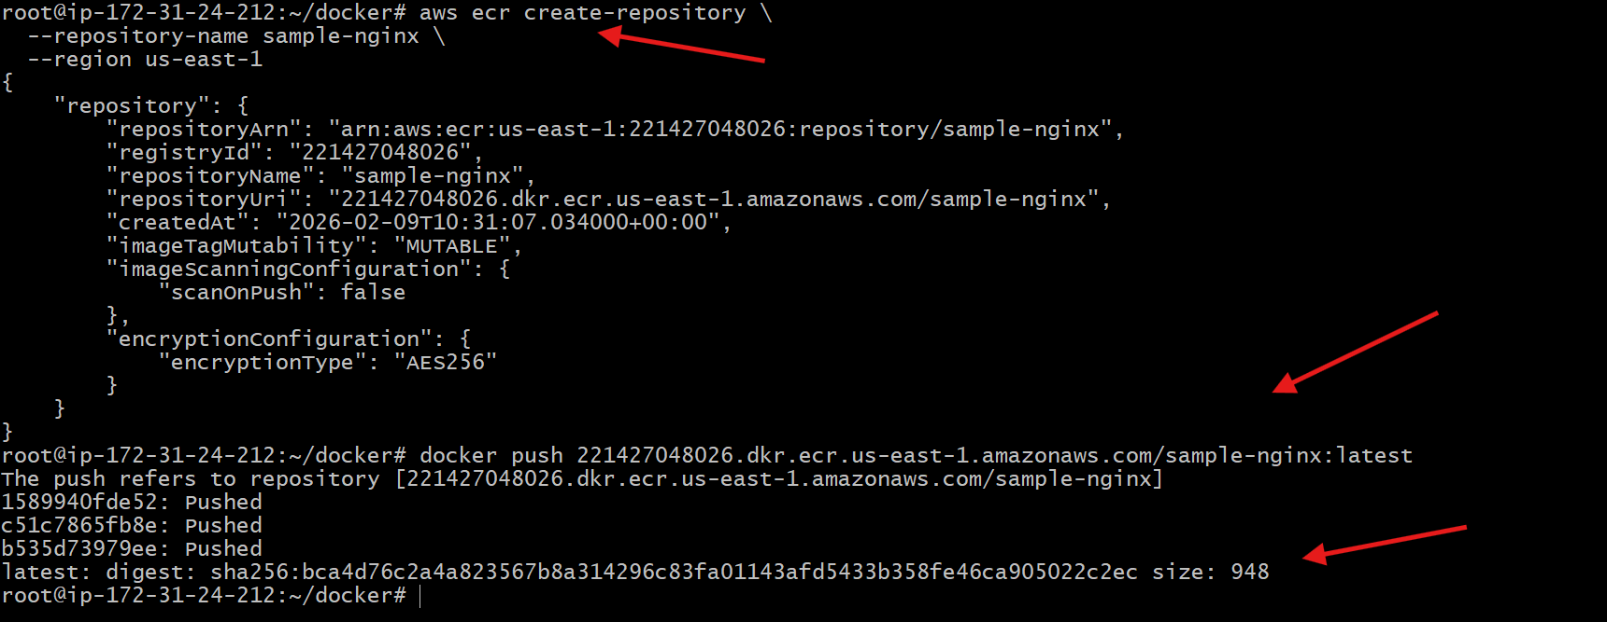
6. Verified the image in AWS Console
You opened the AWS Console and navigated to:
Amazon ECR → Private registry → Repositories
Confirmed:
- Repository sample-nginx exists
- Image tag latest is present
- Image successfully stored in ECR
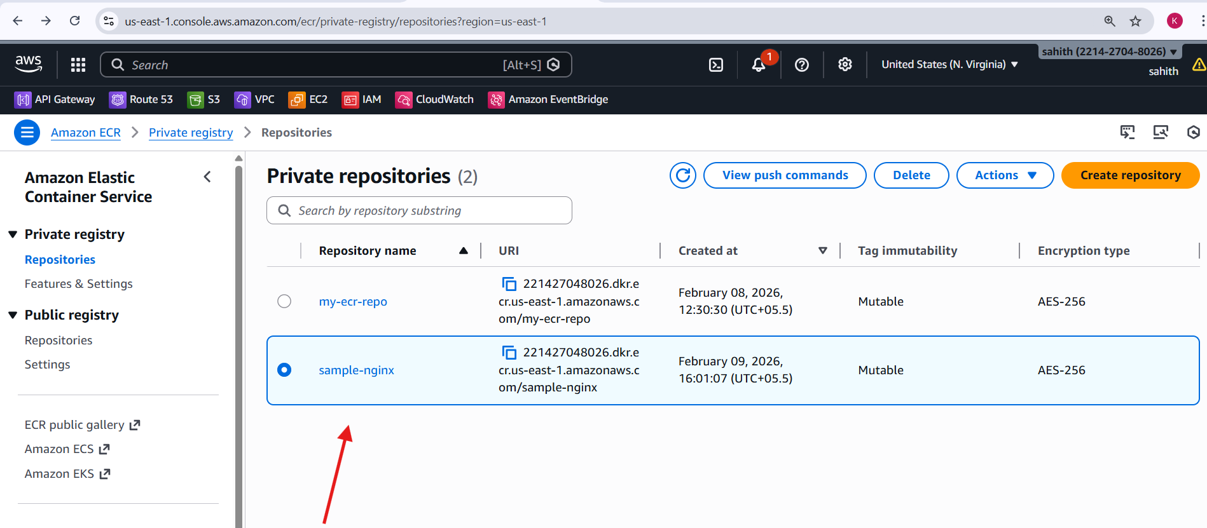

Provision one EC2 instance using Terraform and install Jenkins.
Steps performed:
1. Project Setup
- Created a Terraform project directory aws_instance
- Added three Terraform files only:
  - main.tf
  - variable.tf
  - outputs.tf
2. Variable Configuration (variable.tf)
- Defined all required variables with default values:
  - AWS region: us-east-1
  - AMI ID: ami-0532be01f26a3de55
  - Instance type: m7i-flex.large
  - Key pair name: NV (from NV.pem)
  - Security group: default SG sg-081a2cfcf54433853
- Avoided using terraform.tfvars by using defaults.
3. EC2 Provisioning (main.tf)
- Configured AWS provider using the region variable.
- Created an EC2 instance using:
  - Amazon Linux 2 AMI
  - Custom instance type
  - Existing key pair
  - Existing default security group
- Increased root volume size to 20 GB (gp3).
- Used user_data to automate Jenkins installation.
4. Jenkins Installation via User Data
The following actions were executed automatically during instance boot:
- Updated system packages.
- Installed Java 17 (Amazon Corretto).
- Added Jenkins official YUM repository.
- Imported Jenkins GPG key.
- Installed Jenkins package.
- Explicitly configured Jenkins to use Java:
  - Set JENKINS_JAVA_CMD="/usr/bin/java".
- Reloaded systemd and enabled Jenkins service.
- Started Jenkins service successfully.
Main.tf script:
provider "aws" {
region = var.region
}
resource "aws_instance" "jenkins" {
ami = var.ami_id
instance_type = var.instance_type
key_name = var.key_name
vpc_security_group_ids = var.security_group

root_block_device {
volume_size = 20
volume_type = "gp3"
}
user_data = <<-EOF
#!/bin/bash
set -e
yum update -y
# Install Java 17 (LTS)
yum install -y java-17-amazon-corretto

# Add Jenkins repository
wget -O /etc/yum.repos.d/jenkins.repo https://pkg.jenkins.io/redhat-stable/jenkins.repo
rpm --import https://pkg.jenkins.io/redhat-stable/jenkins.io-2023.key
# Install Jenkins
yum install -y jenkins
# Explicit Java configuration for Jenkins
echo 'JENKINS_JAVA_CMD="/usr/bin/java"' >> /etc/sysconfig/jenkins
# Ensure correct permissions
mkdir -p /var/lib/jenkins
chown -R jenkins:jenkins /var/lib/jenkins
# Start Jenkins
systemctl daemon-reexec
systemctl daemon-reload
systemctl enable jenkins
systemctl start jenkins
EOF
tags = {
Name = "jenkins_terraform"
}
}

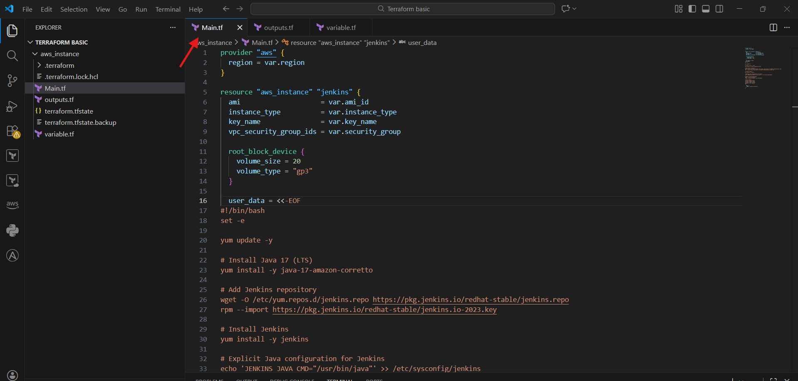
5. Terraform Outputs (outputs.tf)
- Configured outputs to display:
  - EC2 Instance ID
  - Public IP address
  - Public DNS name
  - Jenkins Web URL (http://<public_ip>:8080)
6. Terraform Execution
- Ran the following Terraform commands in sequence:
- terraform init
- terraform validate
- terraform plan
- terraform apply
- Confirmed the apply with yes.
- Terraform successfully created the EC2 instance.
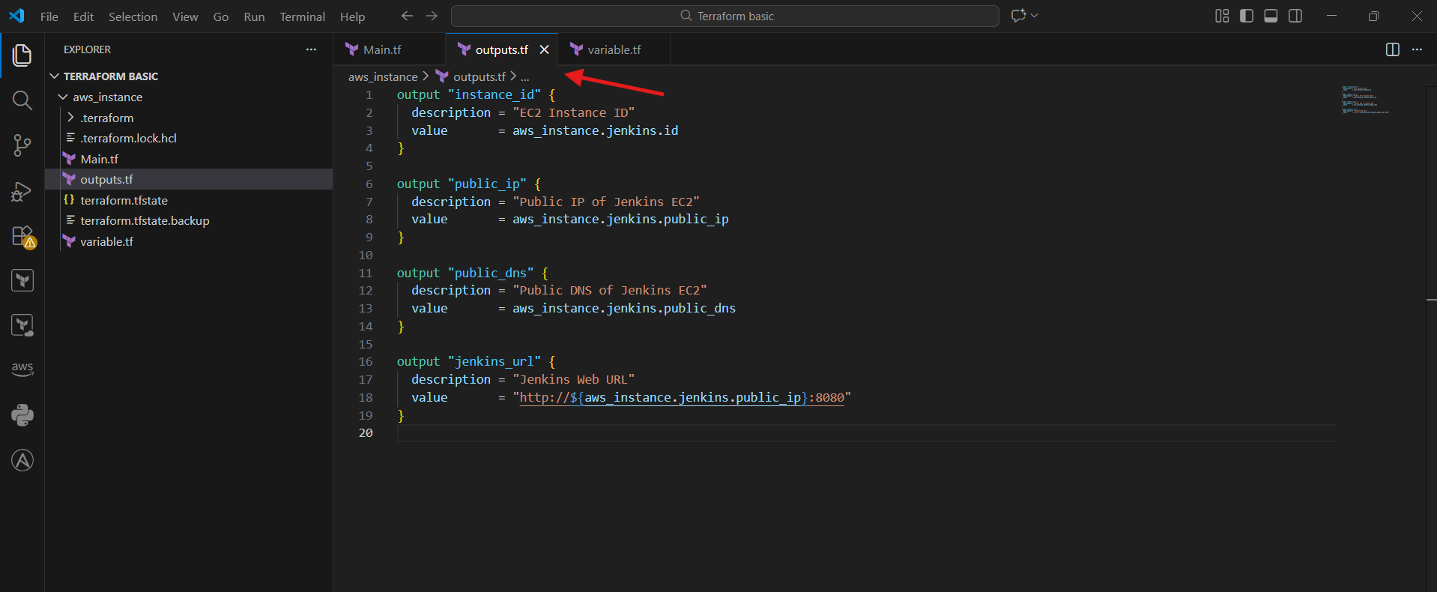
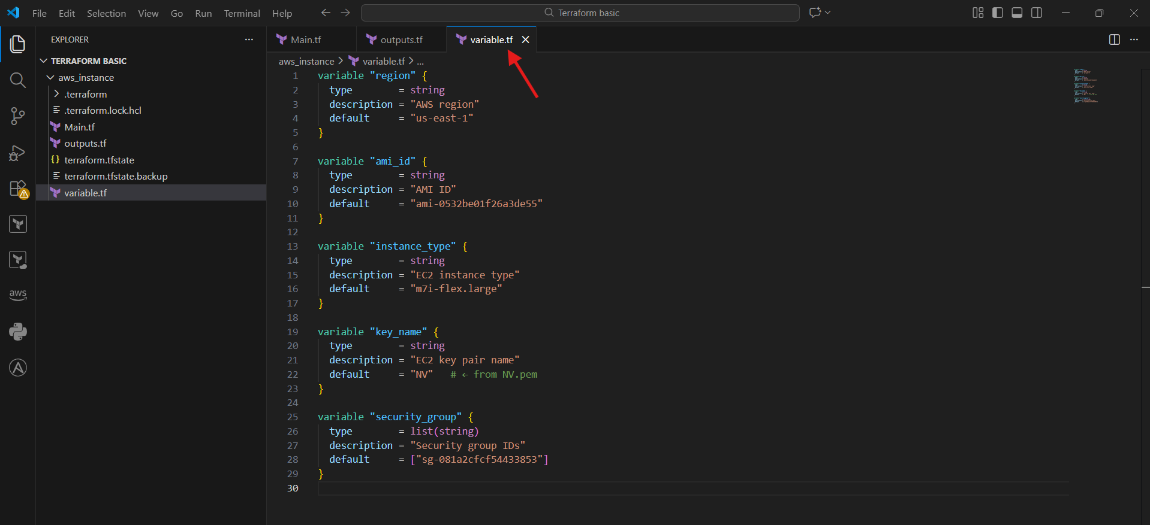
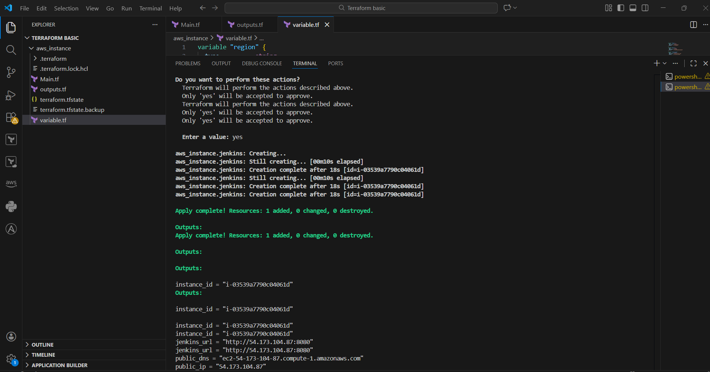
7. Verification in AWS Console
- Verified EC2 instance state as Running.
- Confirmed instance type, public IP, and tags.
- Confirmed security group association.
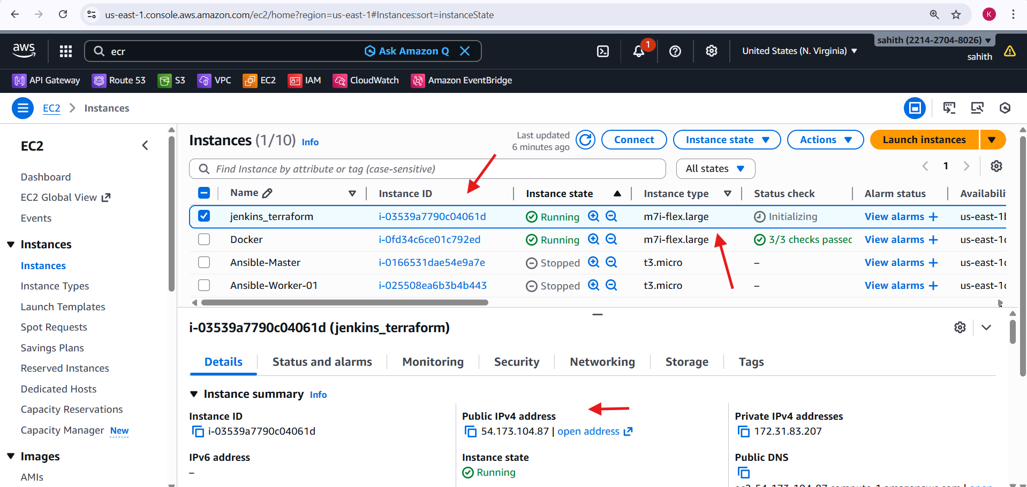
8. Jenkins Service Validation
- Connected to the instance using SSH with NV.pem.
- Checked Jenkins service status:
- systemctl status jenkins
- Verified Jenkins service is active (running).
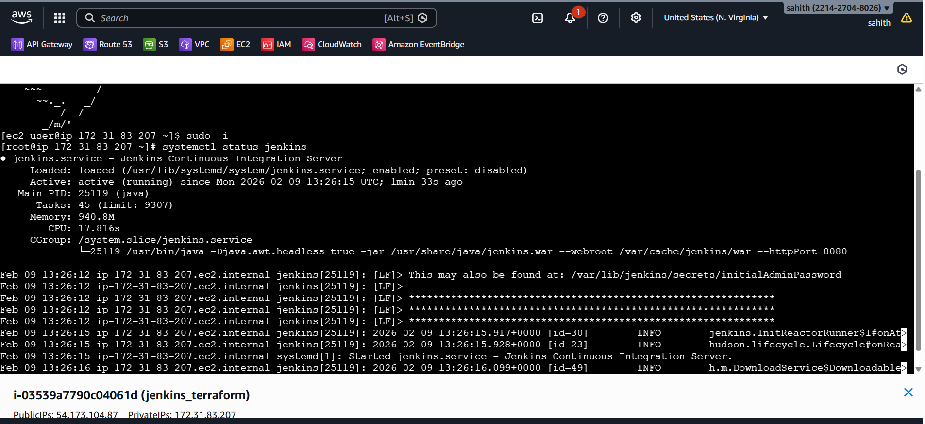
9. Jenkins Initial Setup
- Retrieved Jenkins initial admin password:
- cat /var/lib/jenkins/secrets/initialAdminPassword
- Accessed Jenkins UI using the public IP on port 8080.
- Completed Jenkins unlock and setup wizard.
- Reached the Jenkins dashboard successfully.
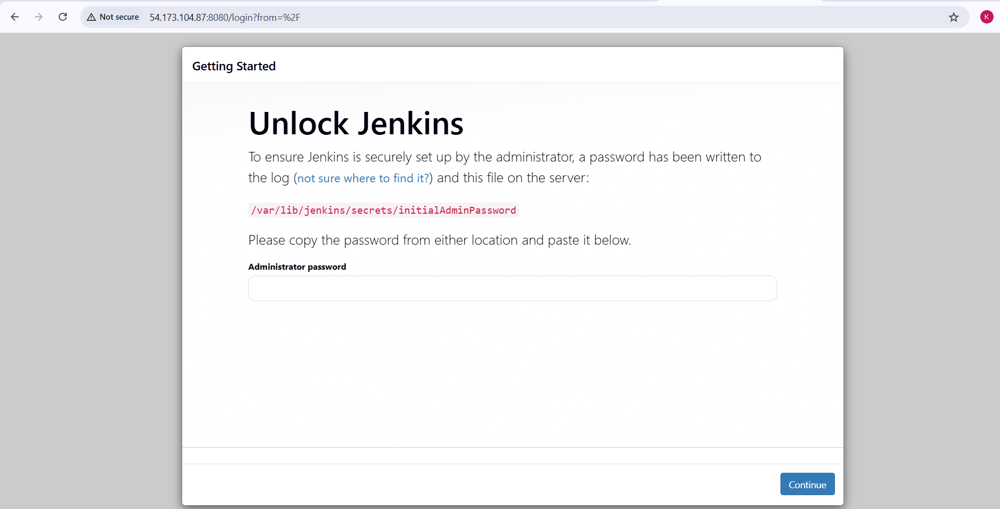
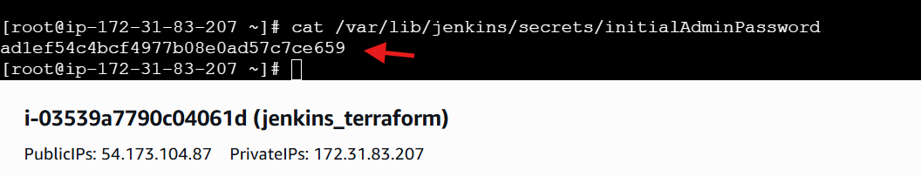
10. Final Result
- EC2 instance provisioned using Terraform.
- Jenkins installed and running automatically.
- Jenkins accessible via browser.
- Infrastructure fully reproducible using Terraform code.
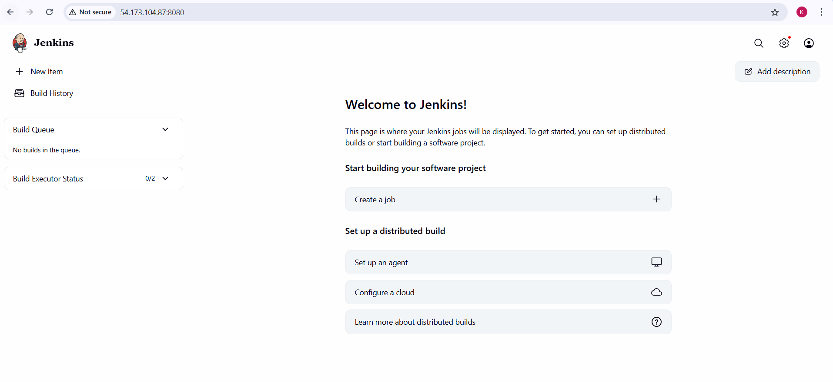

Create one Jenkins job to build and push the Docker image to Docker Hub.
- Source: https://github.com/betawins/Python-app.git
Steps performed:
1. Installed Git on Jenkins EC2 Server
- Logged in as root user on Amazon Linux 2023 EC2
- Ran:
- yum install git
Purpose:
Git is required for Jenkins to clone source code from GitHub.
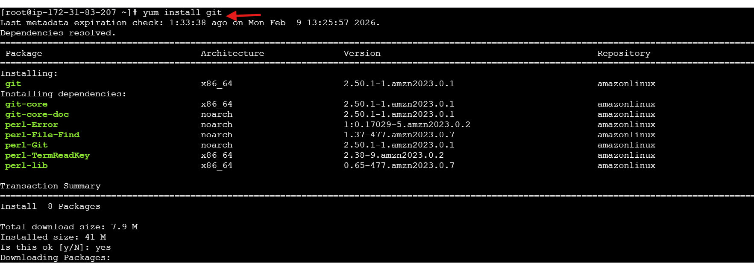
2. Installed Docker on Jenkins EC2 Server
- Executed:
- yum install docker
Purpose:
Docker is needed to build and push Docker images from Jenkins.
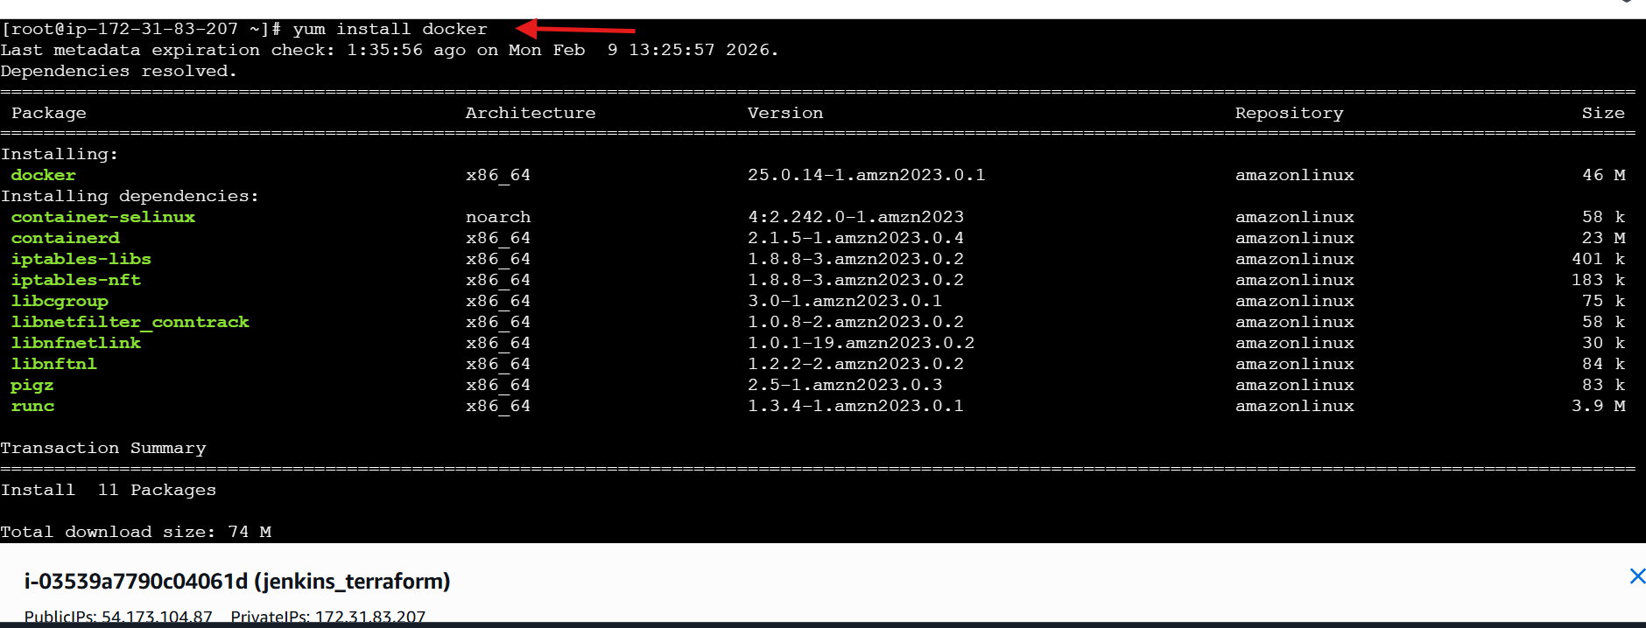
3. Added Jenkins User to Docker Group
- Ran:
- sudo usermod -aG docker jenkins
- Restarted services:
- systemctl restart docker
- systemctl restart jenkins
Purpose:
Allows Jenkins to run Docker commands without sudo.
4. Retrieved Jenkins Initial Admin Password
- Ran:
- cat /var/lib/jenkins/secrets/initialAdminPassword
- Used this password to log in to Jenkins UI
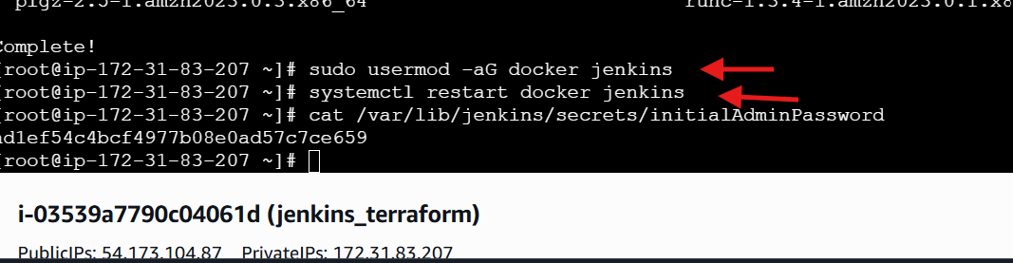
5. Installed Git Plugin in Jenkins
- Navigated to:
- Manage Jenkins → Plugins → Available Plugins
- Searched for git
- Selected:
  - Git Server Plugin
- Clicked Install
Purpose:
Allows Jenkins pipelines to clone GitHub repositories.
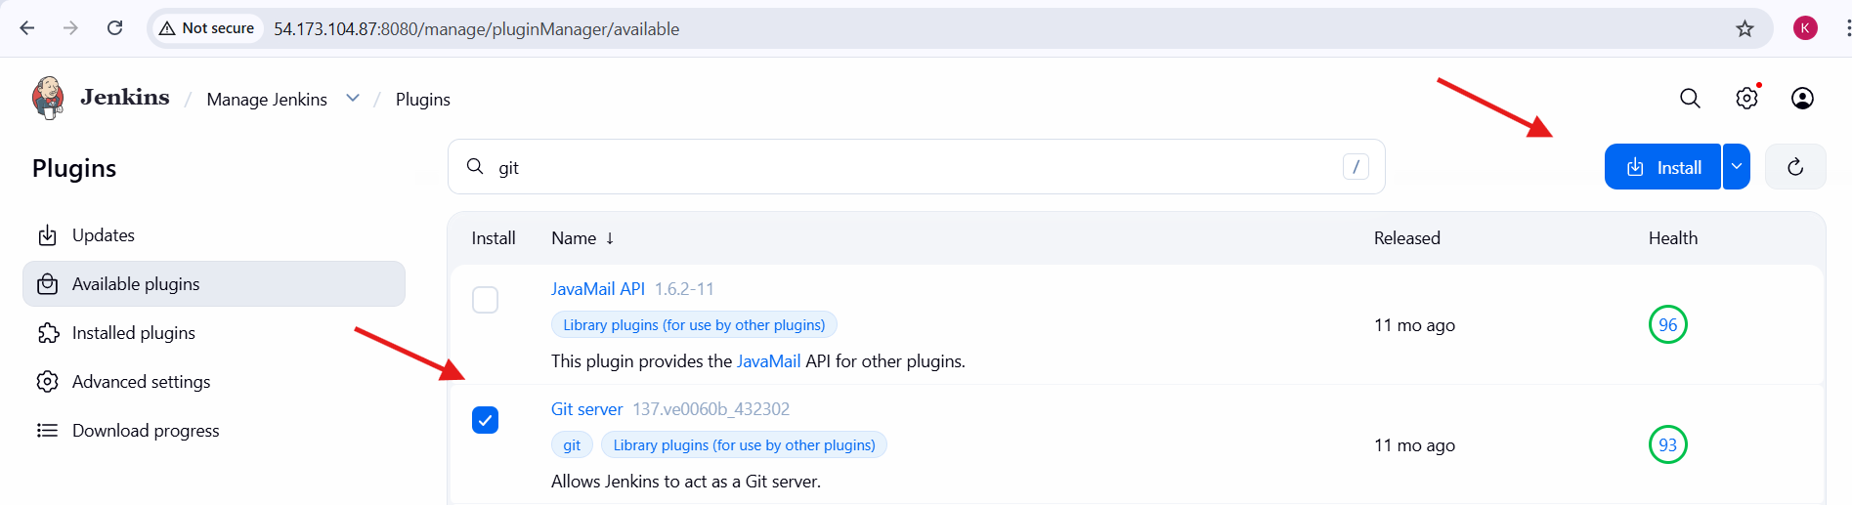
6. Installed Docker Plugins in Jenkins
- In Available Plugins, searched for docker
- Installed:
  - Docker
  - Docker Commons
  - Docker Pipeline
  - Docker API
Purpose:
Enables Docker build, login, and push stages inside Jenkins pipelines.
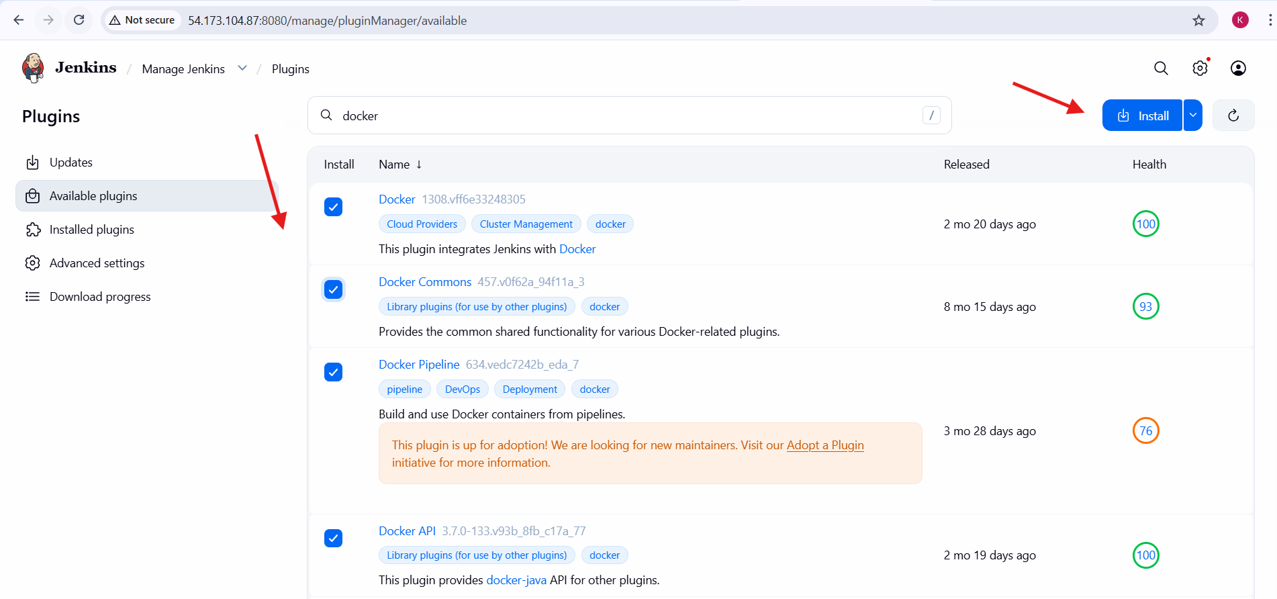
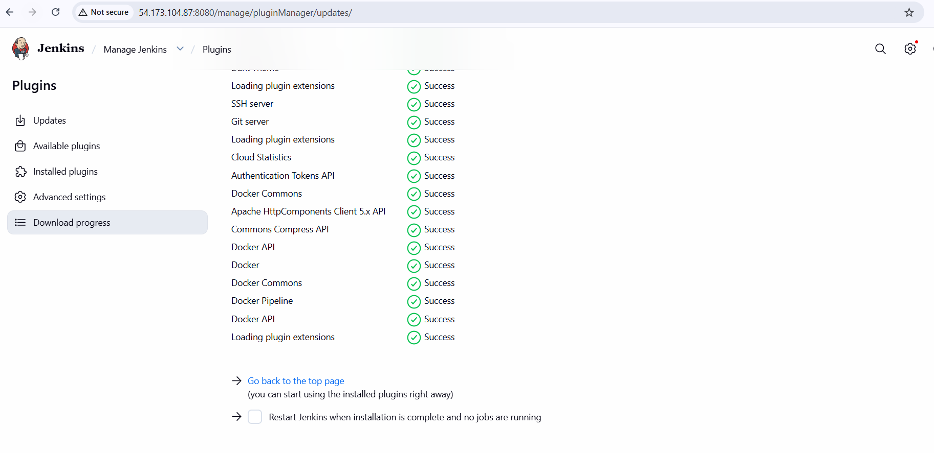
7. Added DockerHub Credentials in Jenkins
- Navigated to:
- Manage Jenkins → Credentials → System → Global credentials
- Added credentials:
  - Username: krishnav7090
  - Password: DockerHub password / token
  - ID used for Docker login
Purpose:
Secure authentication for pushing Docker images to DockerHub.
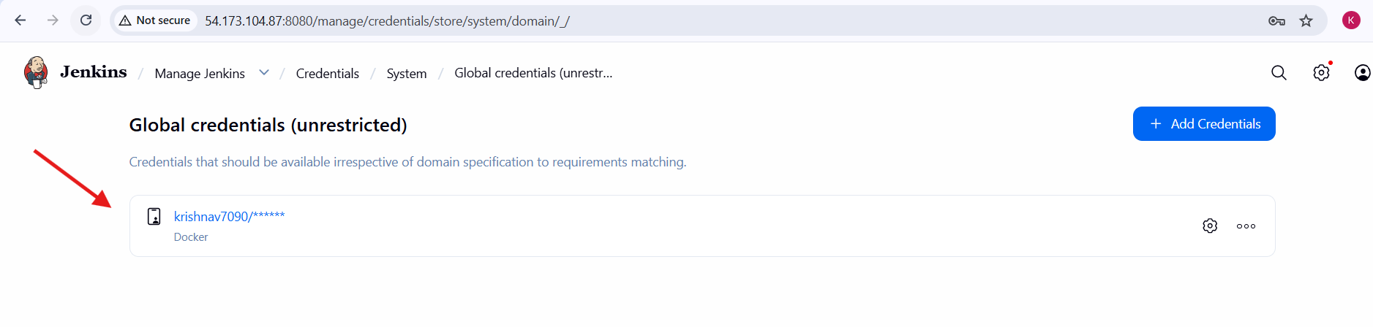
8. Created a New Jenkins Pipeline Job
- Clicked New Item
- Job name:
- Docker-Pythonapp
- Selected Pipeline
- Clicked OK
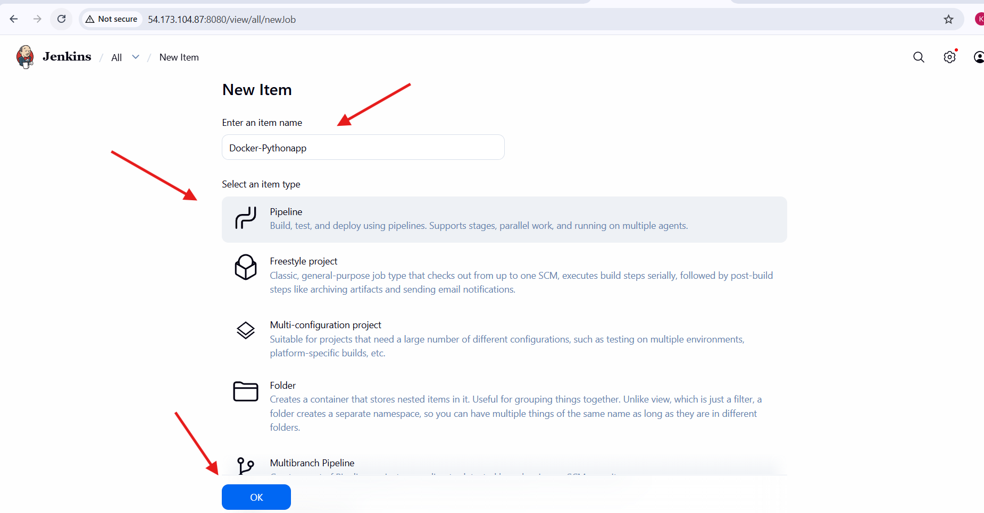
9. Configured Jenkins Pipeline Script
- In Pipeline → Definition, selected:
- Pipeline script
- Added Groovy pipeline script with stages:
  - Checkout Code (GitHub repo)
  - Build Docker Image
  - Login to DockerHub
  - Push Docker Image
- Clicked Save / Apply
Purpose:
Automates Docker image build and push process.
Script:
pipeline {
agent any
environment {
IMAGE_NAME = "krishnav7090/python-app"
TAG = "v1"
}
stages {
stage('Checkout Code') {
steps {
git branch: 'main', url: 'https://github.com/betawins/Python-app.git'
}
}
stage('Build Image') {
steps {
sh 'docker build -t $IMAGE_NAME:$TAG .'
}
}
stage('Login to DockerHub') {
steps {
withCredentials([usernamePassword(
credentialsId: 'Docker',
usernameVariable: 'USER',
passwordVariable: 'PASS'
)]) {
sh 'echo $PASS | docker login -u $USER --password-stdin'
}
}
}
stage('Push Image') {
steps {
sh 'docker push $IMAGE_NAME:$TAG'
}
}
}
}
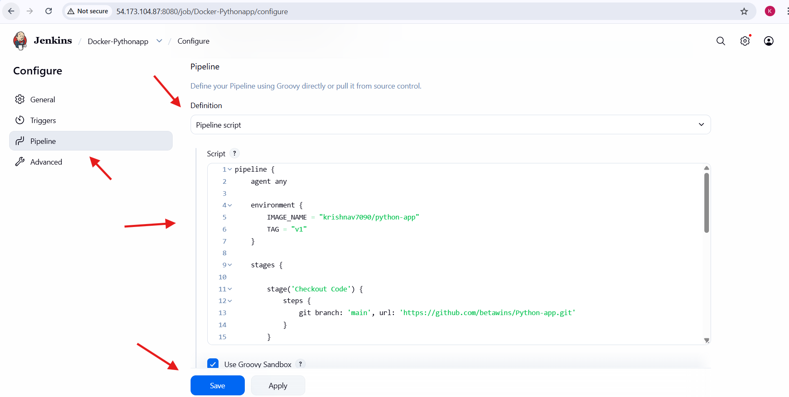
10. Triggered Jenkins Build
- Clicked Build Now
- Pipeline executed stages:
  - Checkout Code
  - Build Image
  - Docker Login
  - Push Image (initial failures)
- Subsequent build succeeded
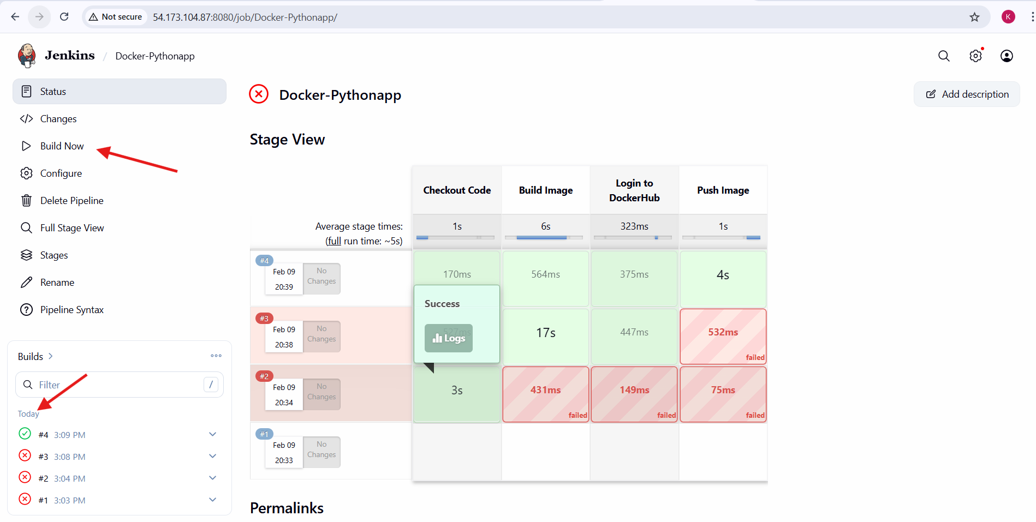
11. Verified Image in DockerHub
- Logged into Docker Desktop / DockerHub
- Confirmed image:
- krishnav7090/python-app:v1
- Image successfully pushed and visible
Final Outcome
- Jenkins successfully:
  - Pulled code from GitHub
  - Built Docker image
  - Authenticated to DockerHub
  - Pushed image to DockerHub registry
You’ve essentially completed a CI pipeline: GitHub → Jenkins → DockerHub
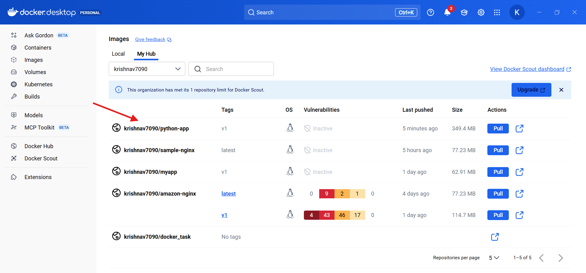

Source Codes: https://github.com/betawins/docker-tasks.git
From the frontend source code, write a Dockerfile, build a Docker image, run it, and push that image to your Docker registry.
Steps performed:
1.Opened GitHub and copied the HTTPS clone URL of the repository
https://github.com/betawins/docker-tasks.git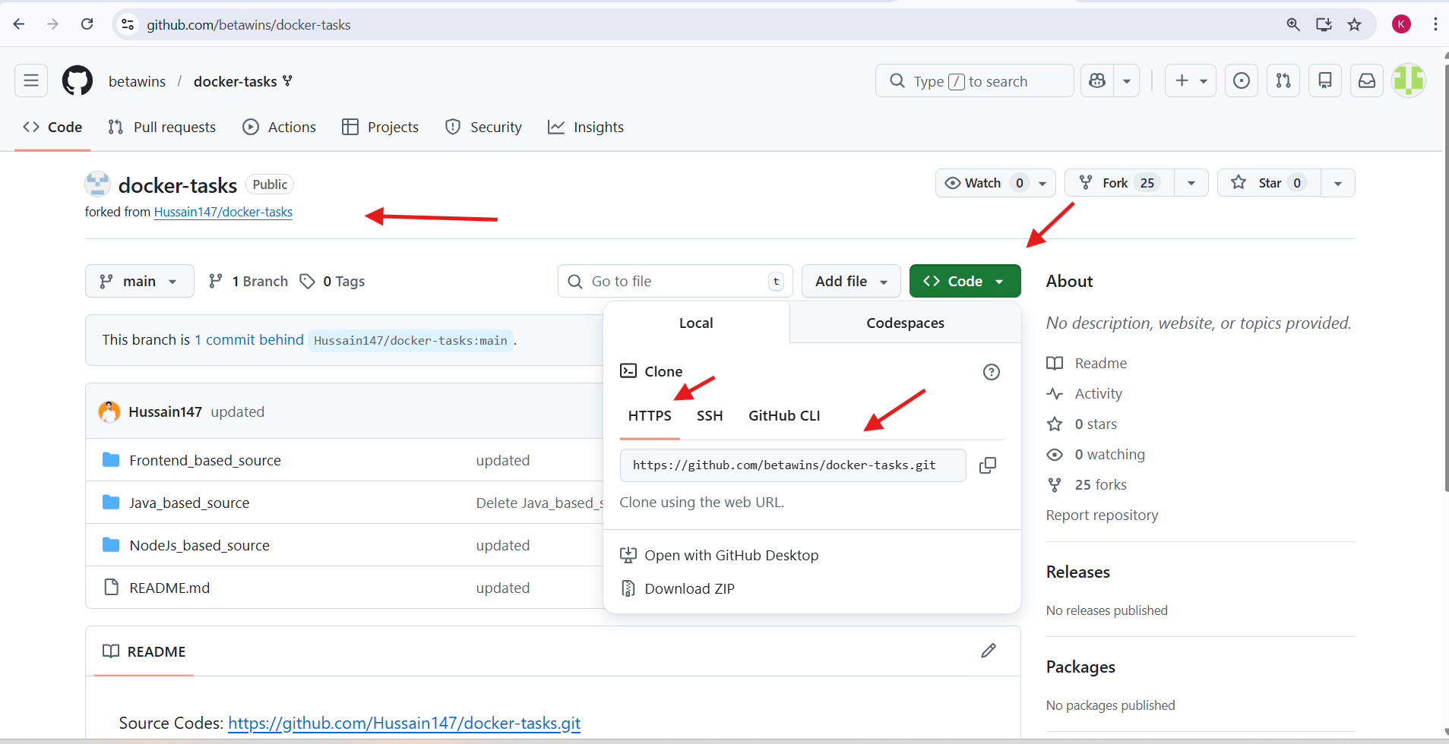
2. Logged into the EC2 Linux server and created a directory:
mkdir source-code
3.Moved into the directory:
cd source-code
4. Cloned the GitHub repository:
git clone https://github.com/betawins/docker-tasks.git
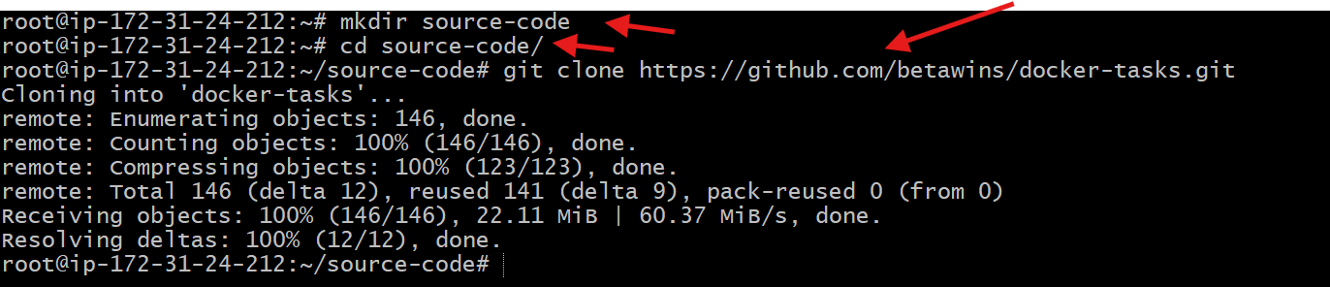
5. Listed files and entered the cloned repository:
ls
cd docker-tasks
6.Verified repository contents:
ls
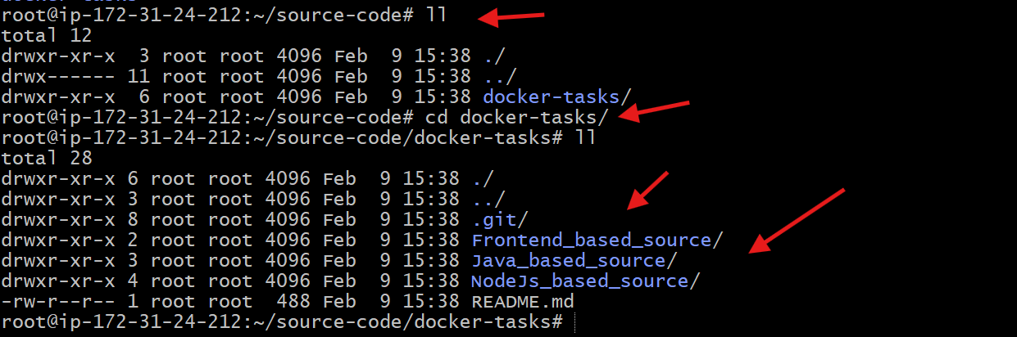
7.Created a Dockerfile:
vi dockerfile
8.Added Dockerfile content using nginx:latest as base image, removed default nginx content, copied index.html, exposed port 80, and started nginx in foreground.
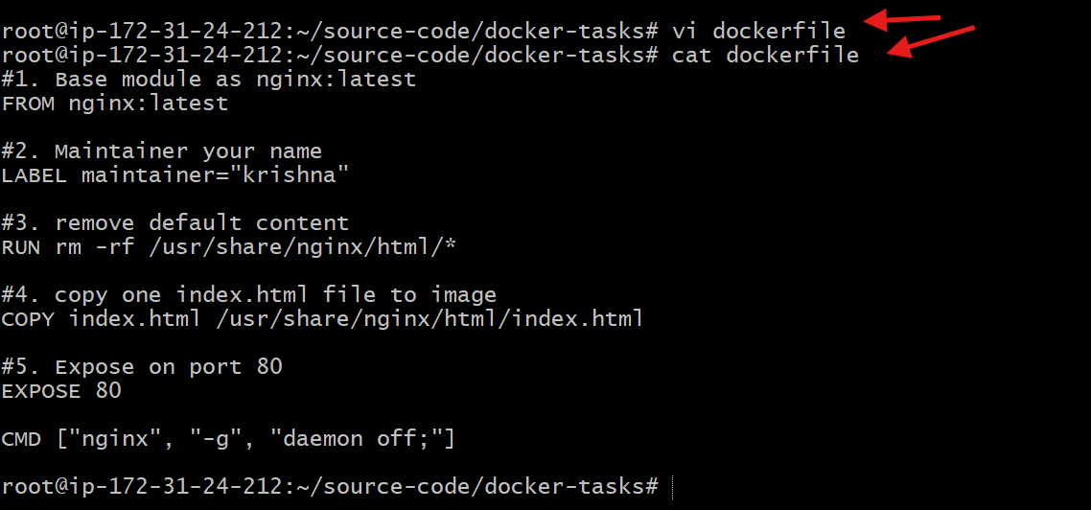
9.Created the frontend HTML file:
vi index.html
10.Verified files in directory:
Ls
11.Built the Docker image:
docker build -t krishnav7090/frontend-app:v1 .
12.Confirmed image build completed successfully.
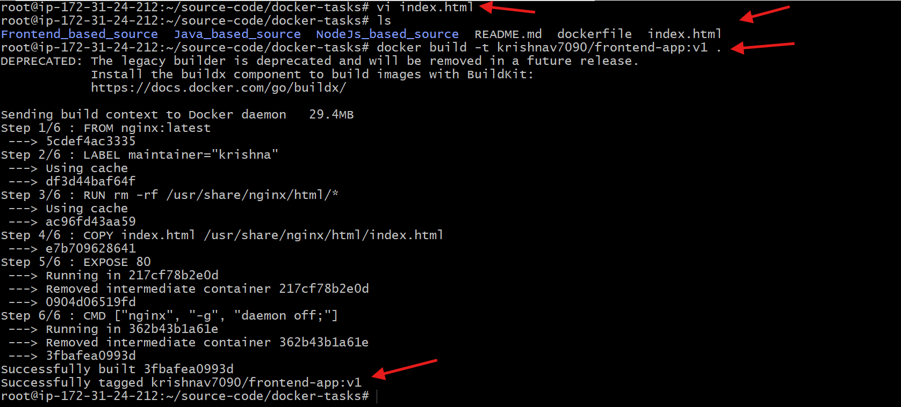
13.Ran the Docker container and mapped ports:
docker run -d -p 8084:80 krishnav7090/frontend-app:v1
14.Verified running containers:
docker ps
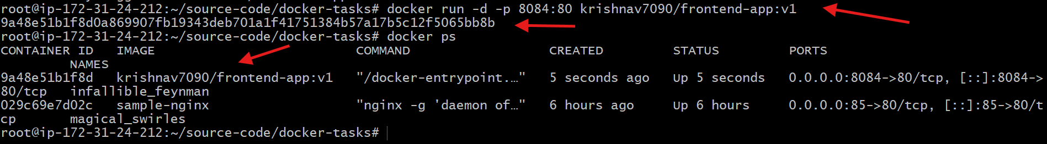
15.Accessed the application in browser using:
http://<EC2-Public-IP>:8084
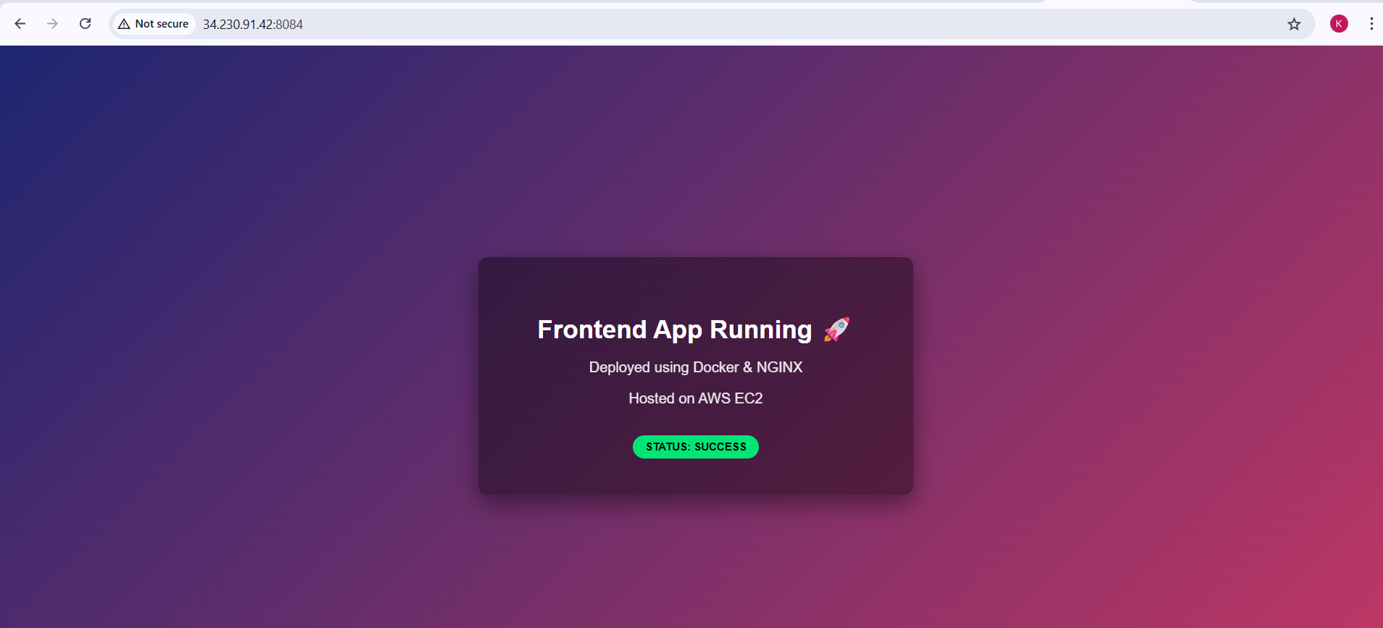
16.Logged in to Docker Hub:
docker login
17.Pushed the Docker image to Docker Hub:
docker push krishnav7090/frontend-app:v1
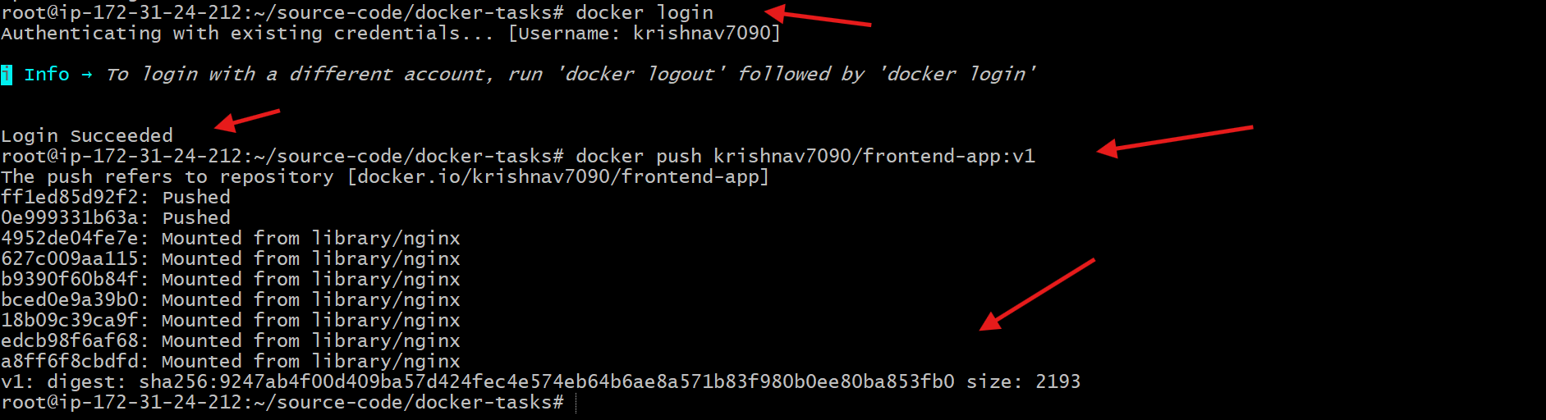
18.Verified the image is available in Docker Hub.
19.Opened Docker Desktop and confirmed the image appears under local images.
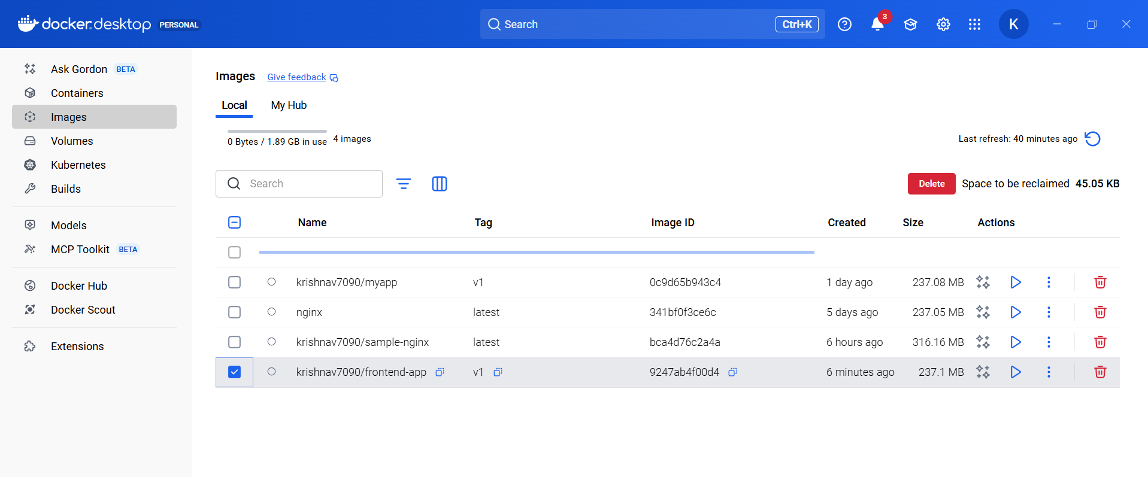
From the Java-based source code, write a Dockerfile, build, run, and push the image to the Docker registry.
Steps performed:
- Created a directory to store source code:
mkdir source-code
- Moved into the directory:
cd source-code
- Cloned the GitHub repository:
git clone https://github.com/betawins/docker-tasks.git
- Verified the cloned repository:
ls

- Entered the repository directory:
cd docker-tasks
- Listed repository contents:
ls
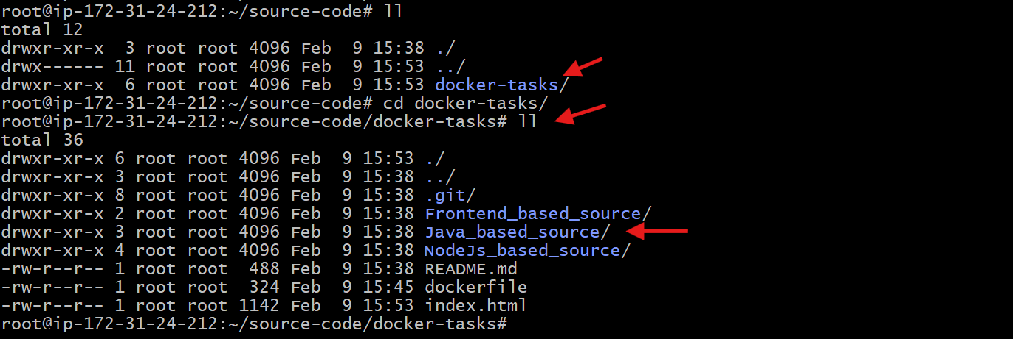
- Navigated to Java-based source code:
cd Java_based_source
- Verified Java project files (pom.xml and src):
ll
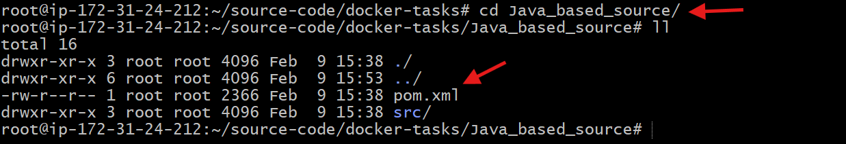
- Created a multi-stage Dockerfile:
vi dockerfile
- Added Dockerfile with Maven build stage and JRE runtime stage.
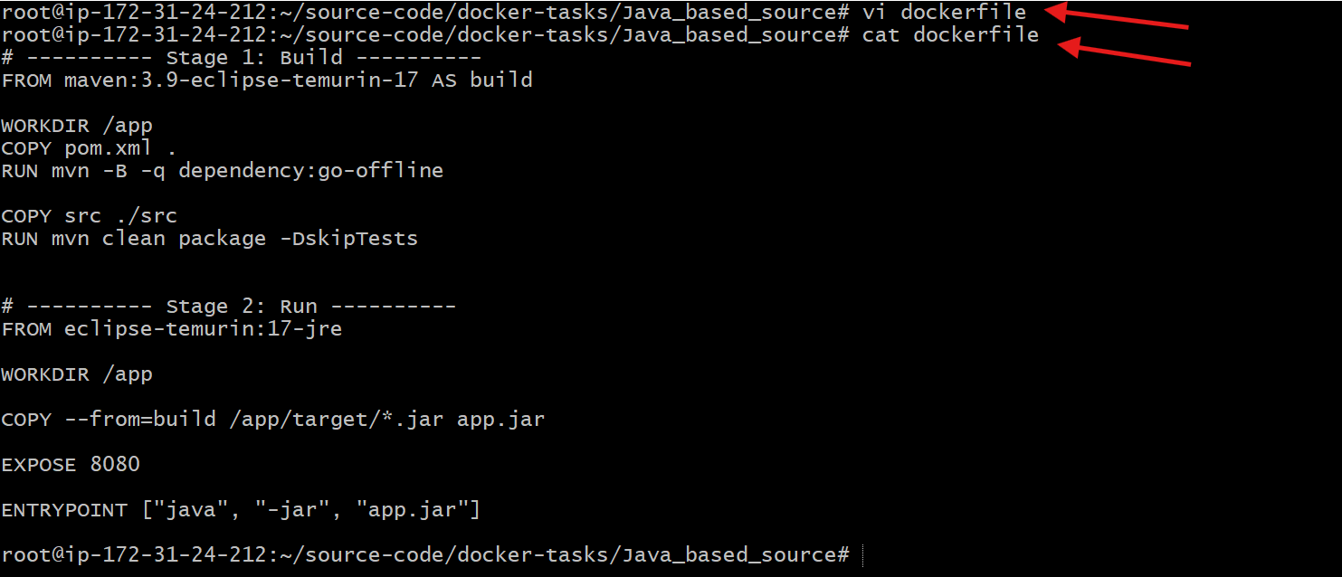
- Built the Docker image for the Java application:
docker build -t krishnav7090/java-app:v1 .
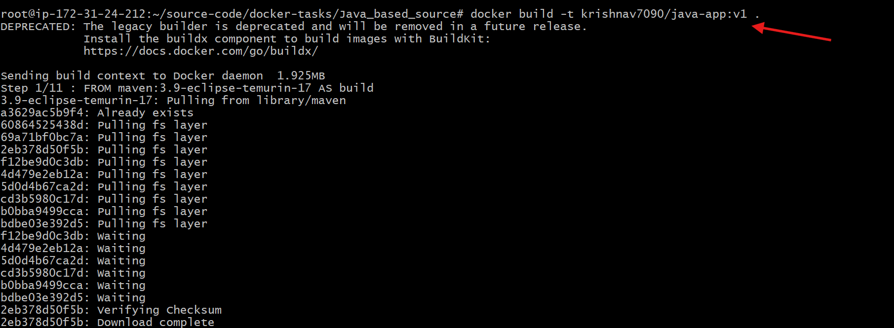
- Confirmed the Docker image build completed successfully.
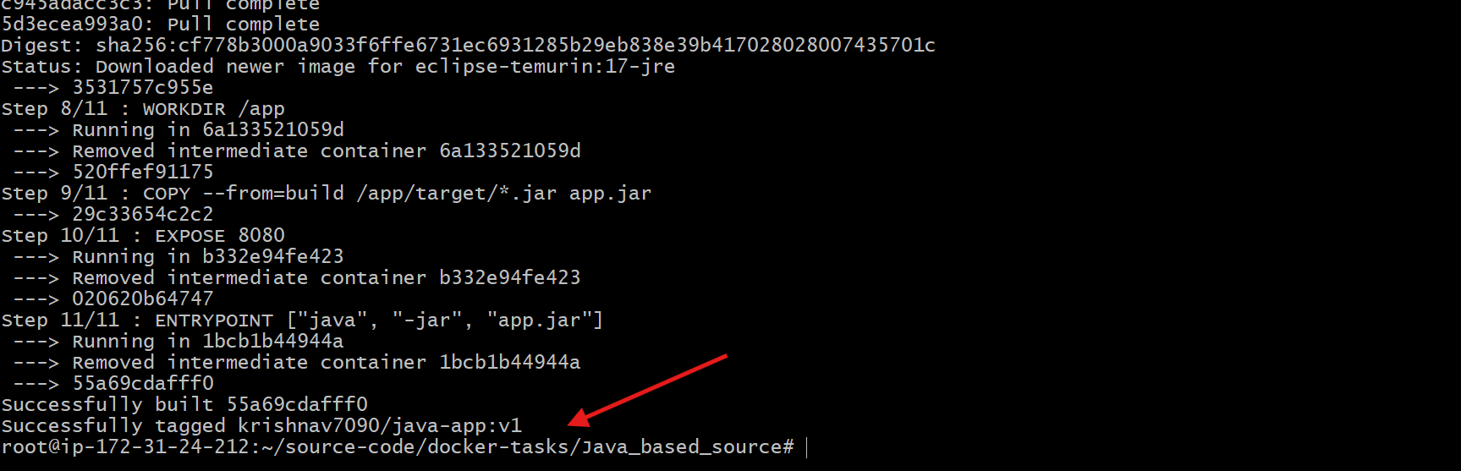
- Ran the Java application container with port mapping:
docker run -d -p 8085:8080 krishnav7090/java-app:v1
- Verified running containers:
docker ps
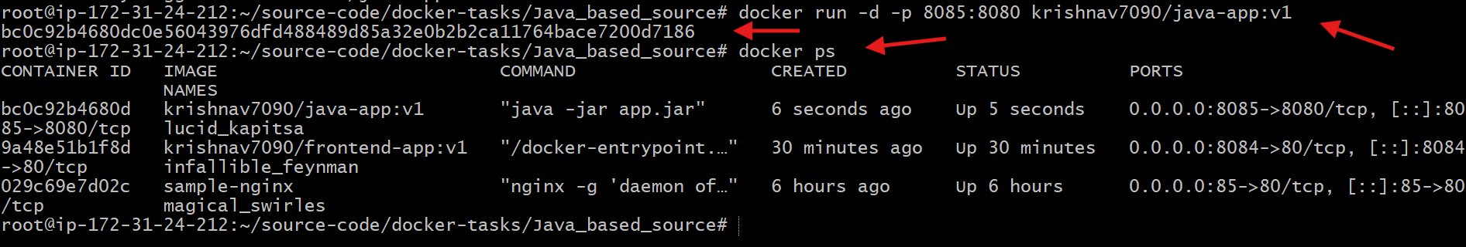
- Accessed the Java application in a browser:
http://<EC2-Public-IP>:8085
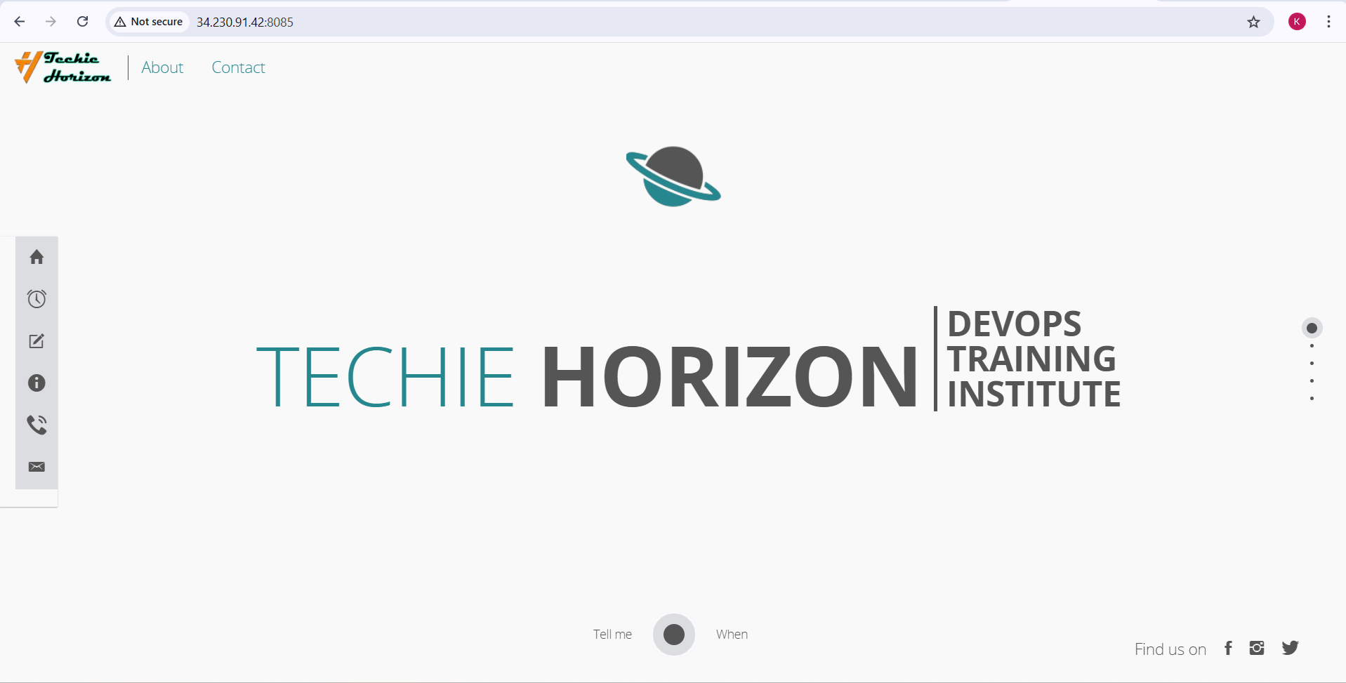
- Logged in to Docker Hub:
docker login
- Pushed the Java application image to Docker Hub:
docker push krishnav7090/java-app:v1
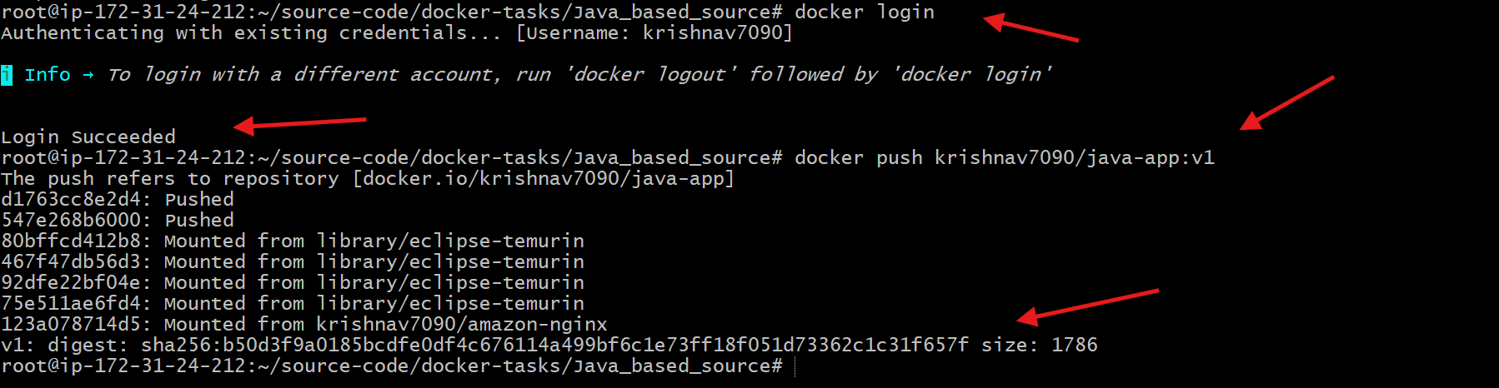
- Verified the image is available in Docker Hub repository.
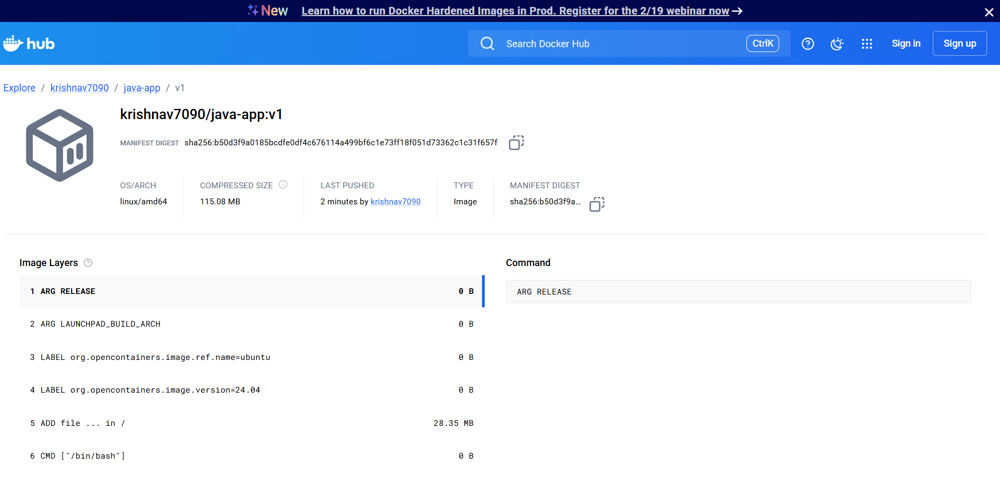

From the Node.js-based source code, write a Dockerfile, build with tag v1, run, and push it to the Docker registry.
Steps performed:
- Created a directory to store source code:
mkdir source-code
- Moved into the directory:
cd source-code
- Cloned the GitHub repository:
git clone https://github.com/betawins/docker-tasks.git
- Verified the cloned repository:
ls

- Entered the repository directory:
cd docker-tasks
- Listed repository contents:
ls

- Navigated to NodeJS-based source code:
Cd NodeJS_based_source
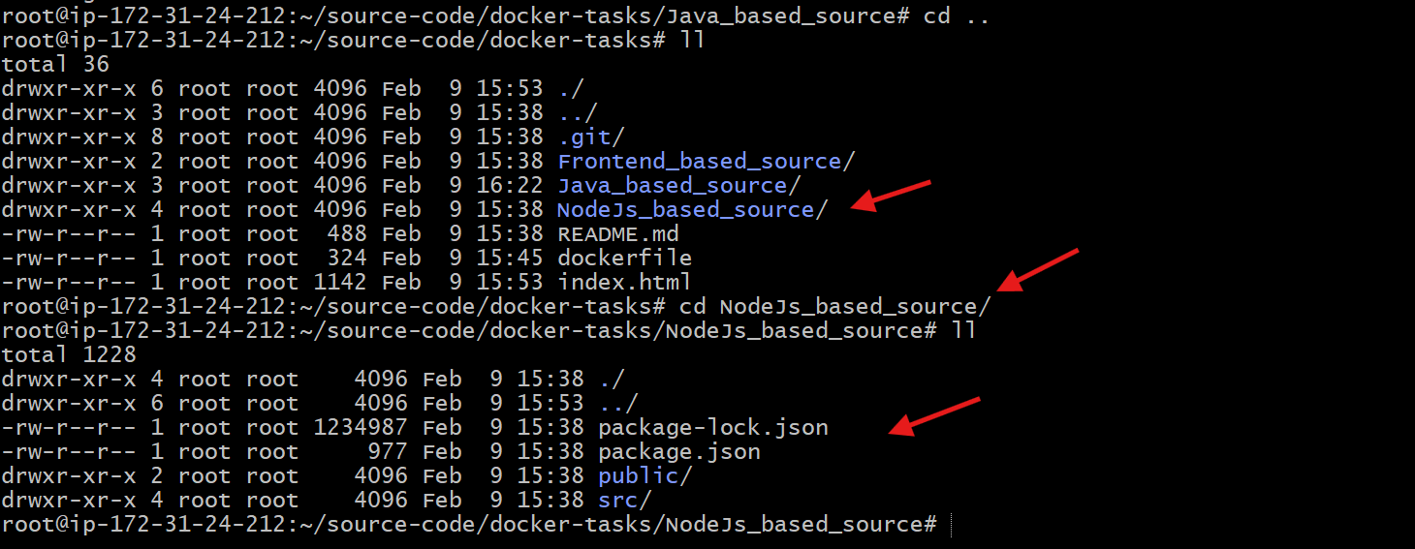
- Created Dockerfile:
vi dockerfile
- Added Dockerfile using node:18-alpine as base image.
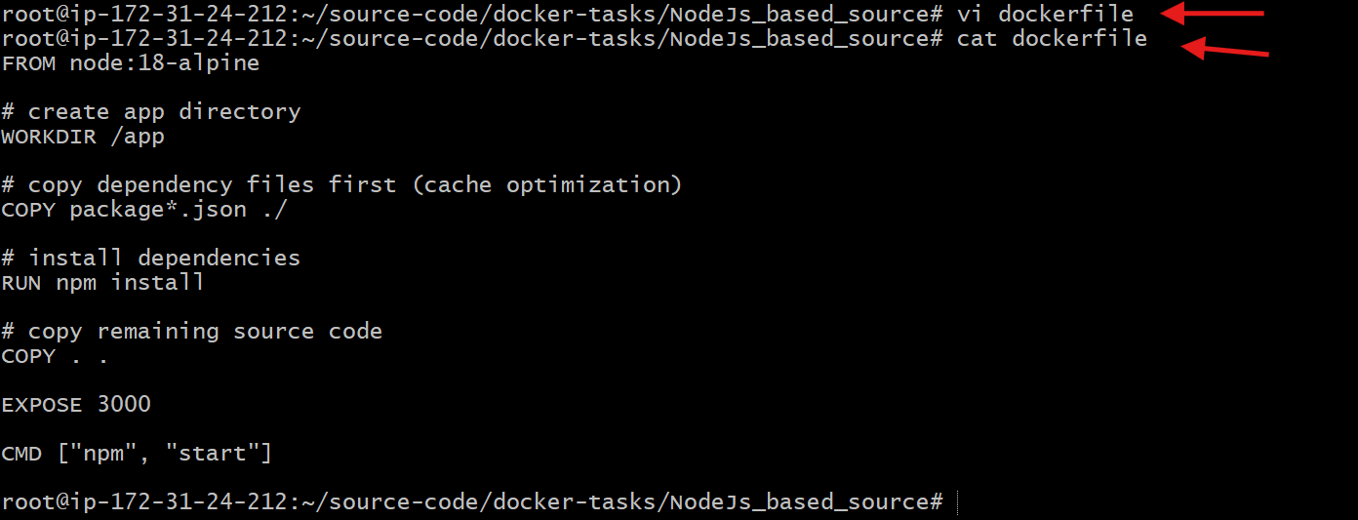
- Built Docker image:
docker build -t krishnav7090/node-app:v1 .
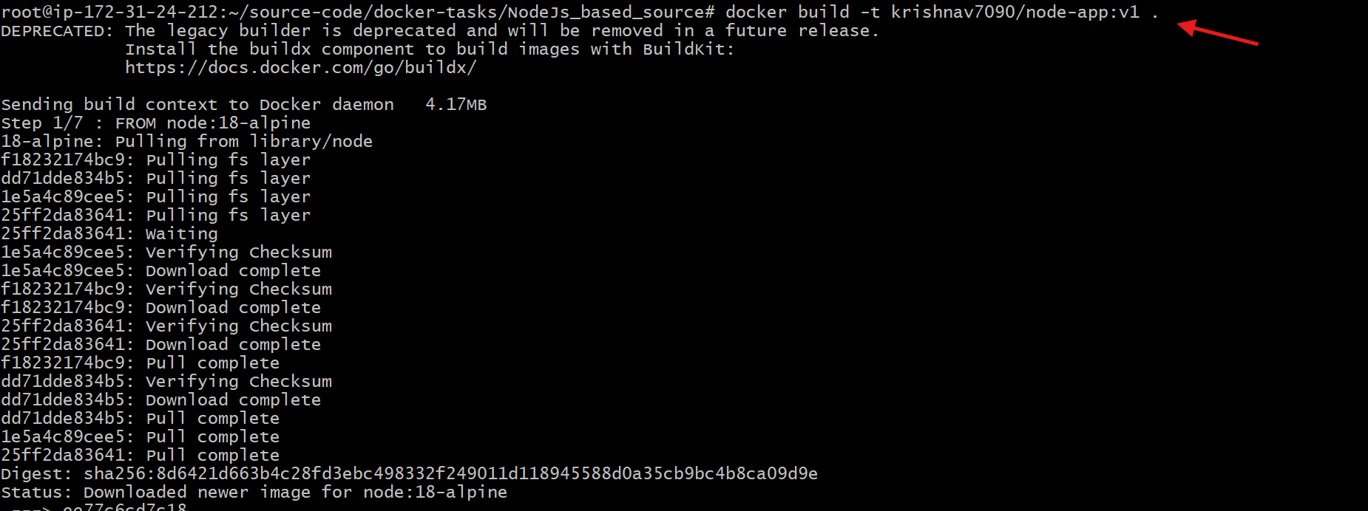
- Confirmed Docker image build completed successfully.
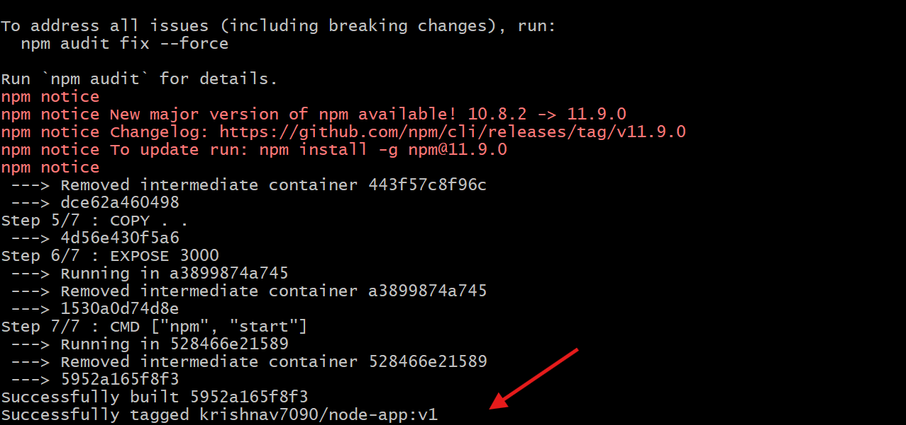
- Ran Node.js container with port mapping:
docker run -d -p 3000:3000 krishnav7090/node-app:v1
- Verified running containers:
docker ps
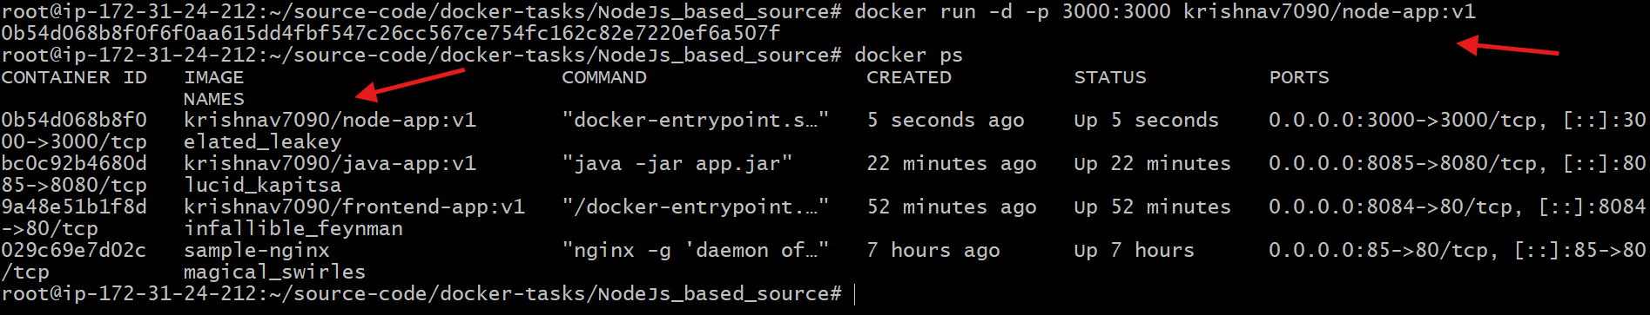
- Accessed Node.js application in browser:
http://<EC2-Public-IP>:3000
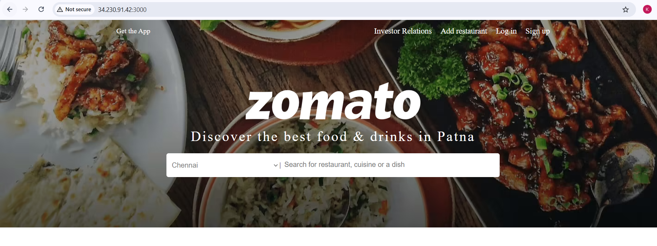
- Logged in to Docker Hub:
docker login
- Pushed Node.js image to Docker Hub:
docker push krishnav7090/node-app:v1
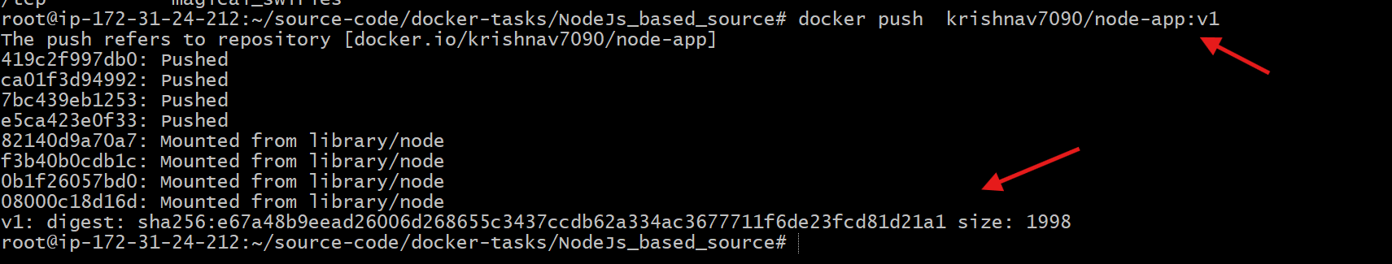
- Verified image available in Docker Hub repository.
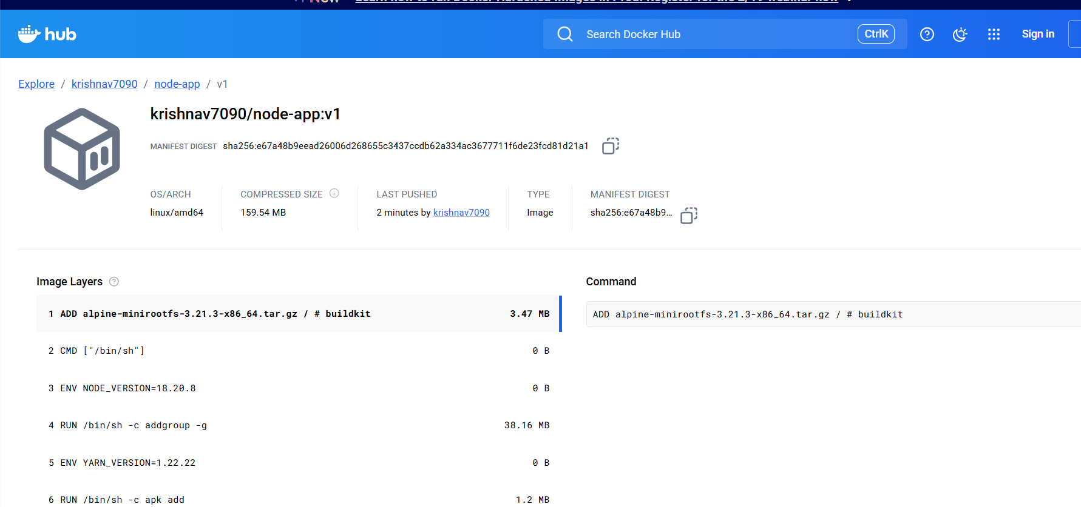

Write a docker-compose file to set up WordPress with a MySQL database.
Steps performed:
- Created Docker Compose file:
vi compose.yml
- Added Docker Compose configuration for MySQL and WordPress.
- Verified the compose file:
cat compose.yml
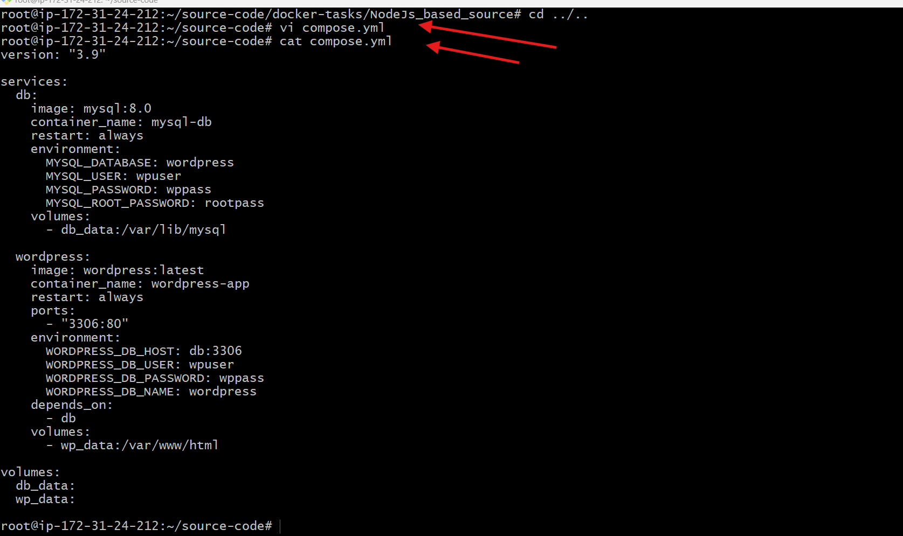
- Started containers using Docker Compose:
docker-compose up -d
- Docker pulled required images (mysql:8.0, wordpress:latest).
- Docker created network and volumes:
  - source-code_db_data
  - source-code_wp_data
Containers started:
  - mysql-db
  - wordpress-app
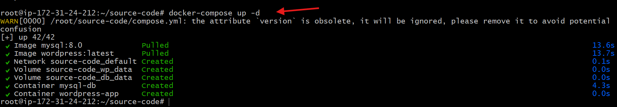
- Opened browser and accessed WordPress installer:
http://<EC2-Public-IP>:3306
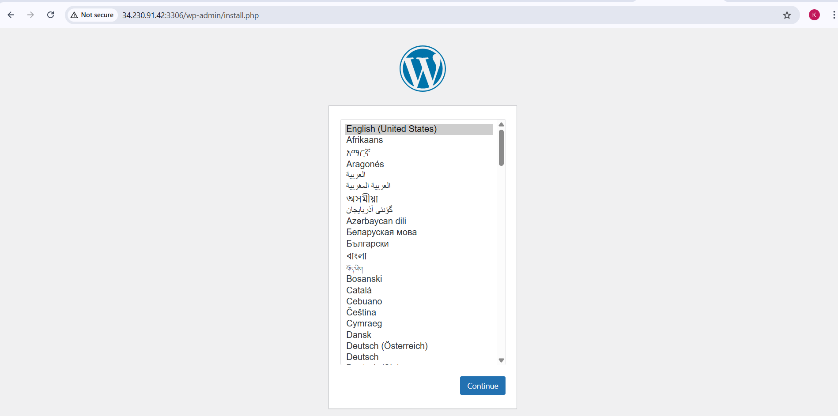
Selected language on WordPress setup page and clicked Continue.
Entered WordPress site details: Site title
Username
Password
Email
Clicked Install WordPress to complete setup.
WordPress installation completed successfully and site became accessible.
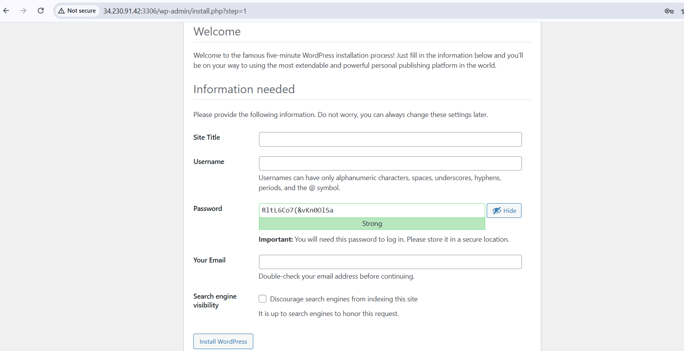
Errors Faced
- Legacy Docker builder deprecation warning
  - Resolved by continuing build (non-blocking warning).
- Port conflicts
  - Fixed by assigning unique host ports for each container.
- Docker Hub authentication issues
  - Resolved by re-logging using docker login.
- WordPress container startup delay
  - Resolved by using depends_on and waiting for MySQL readiness.
- Jenkins permission issues with Docker
  - Resolved by adding Jenkins user to Docker group.
- ECR authentication failure
  - Resolved by re-authenticating using AWS CLI login command.
Conclusion
- Successfully containerized Frontend, Java, Node.js, and Python applications using Docker.
- Built and ran all applications as Docker containers.
- Pushed Docker images to Docker Hub and Amazon ECR.
- Provisioned an EC2 instance using Terraform.
- Installed and configured Jenkins on EC2.
- Automated Docker build and push using a Jenkins job.
- Deployed WordPress with MySQL using Docker Compose.
- Demonstrated a complete DevOps lifecycle:
Code → Build → Containerize → CI/CD → Cloud Deployment → Orchestration

